Risk Assessment and Categories of Risk
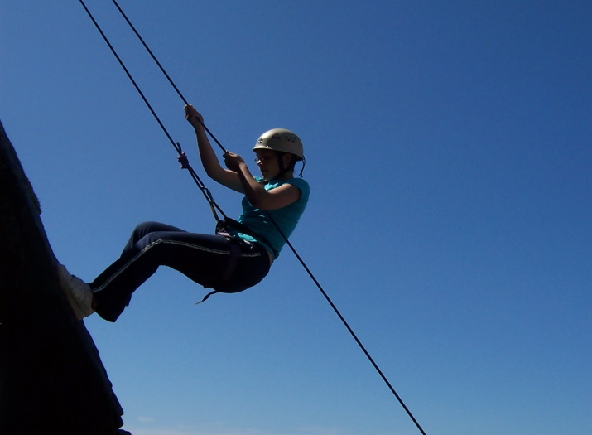

A support Document
created by members of
Girlguiding London and South East England

Risk Assessment Report

We started by looking at and considering comments, questions and concerns put to us by Leaders and Commissioners with various experience and knowledge. These tended to fall into four groups.

Following this we produced paperwork including good practice which would support them and give them the confidence to formalise Risk Assessment when necessary.

FAQS

- How do we as Commissioners know that a Risk Assessment has been done if we don’t see it?

Good practice would be to copy the District Commissioner in with the Risk Assessment at the same time as the programme for Unit Meetings and with other paperwork for other events.

- What should Risk Assessments cover? What should District Commissioners look for?

We have produced a Categories of Risk check list, which is by no means exhaustive, but can be used as a starting point.

- If we do a Risk Assessment and something then goes wrong, we’ll be more liable because we knew about it, but didn’t stop it happening.

Providing written evidence that you have done a risk assessment and taken into account the various factors at the time shows evidence that you have tried to take all possible care, as long as you have then put the procedures into place.

- It’s going to take ages doing written risk Assessments for every meeting!

We suggest a generic Unit Meeting Risk Assessment is done for each venue and then units add their own specific items relating to their own people, programme and circumstances. This will need reviewing once a year and amending when numbers change dramatically, new, more risky activities are introduced or adults or girls with any additional needs join the unit etc

Risk Assessment Good Practice

Accidents do happen and the purpose of risk assessment is not to STOP children taking risks, but rather to ENABLE them to take acceptable risks in as safe an environment as possible. Sadly in this day and age when adults are encouraged to sue for the slightest accident/incident, we as Leaders need to protect ourselves by having tangible evidence. We all risk assess all the time as we go about our daily lives but information in our heads doesn’t provide that concrete evidence should an accident/incident occur.

Risk assessment helps us plan responsibly and provides evidence of our care in the event of an incident. Please remember that the risks involved in any activity/event should be balanced out with the benefit to the girl in terms of her development and ability to assess and cope with acceptable risks.

Should an incident/accident happen, it is quite likely that your District Commissioner would be contacted. In order to give you full and informed support it would be good practice to copy her in on the risk assessment in the same way that you copy her in on your termly plans.

Unit Meetings –

- In the normal Meeting Place –

Written generic risk assessment on the areas used and accessed during a normal meeting to include venue’s own risk assessment.
Written risk assessments for specific activities in the meeting place – these may need updating if numbers change dramatically, girls/adult Leaders have behaviour/age/health issues which may affect the activity or other changes in venue, equipment or personnel take place.

The Leadership Team should also discuss informally any risk issues as they arise at the beginning of or during a meeting

- Away from the normal Meeting Place –

A written risk assessment covering all areas for which the Leadership Team have responsibility is needed.
You do not need to risk assess parents transporting girls to another venue unless a member of the Leadership Team has arranged this, in which case the Team need to check insurance etc You do need Permission forms signed by parents/guardians for these meetings.

The Leadership Team should also discuss informally any risk issues as they arise at the beginning of or during a meeting

- Activities starting and finishing at normal Meeting Place but happening somewhere else –

Common sense must prevail. The joining forms which parents sign cover activities local to the usual Meeting Place however if you are crossing main roads, using deserted country lanes, going to the beach, river or woods it would be good practice to have a written risk assessment as the element of risk is elevated. It is also recommended good practice to visit and travel to and from any venue when it is the first visit or when the venue is such that risk in terms of weather, development of the area, or tides etc may change.

The Leadership Team should also discuss informally any risk issues as they arise at the beginning of or during a meeting

Events and Activities outside normal meeting times –

- A written risk assessment should be carried out for all aspects of the event for which Leaders have responsibility for the girls. The event/activity providers should have a written risk assessment for those aspects for which they have responsibility and Leaders should ask to see it to satisfy themselves that all possible care has been taken.

Accident Forms

- Please note that the Guide Association Accident Forms now have a question which asks if you have completed a Risk Assessment prior to the activity.

Pat Rawson Rosemary Pullen
On behalf of Girlguiding London and South East England

Categories of Risk to consider

This is not an exhaustive list and you may need to add others for your particular activity/event.

Category | Detail | Considered
Finance | Event/activity/Unit budget
 | Contingency/emergency funds
 | Underwriting any over spend
 | Dealing with surplus monies
 | Fund raising
 | Grants
 | Other – Please add your own boxes and titles
Reputation | Guide wear
 | Behaviour
 | Public perception
 | Other – please add your own boxes and titles
Activities | Check Manual – prohibited activity?
 | Suitable for age group
 | Qualified Instructors
 | Suitable clothing/footwear
 | Weather/time of year
 | Suitable venue/space
 | Appropriate equipment
 | Risk Assessment of instructor/provider of activities
 | Other – please add your own boxes and titles
People | Leader Qualifications
 | Members over 65 years
 | Unit Helpers
 | Parent Helpers
 | Members with disabilities
 | Male Unit Helpers/Helpers
 | Visitors
 | D of E Volunteers
 | Non member children
 | Member children non section age group
 | Event numbers
 | Adult/child ratios
 | Home Contact/s
 | Death of a Participant
Equipment | Any items used for an activity or event that is the responsibility of the organising team or participants
 | Electrical – PAT tested
 | Suitability for age group/ability of participants
 | Risk Assessment of instructor/provider of activities
 | Other – please add your own boxes and titles
Meeting Place | See and incorporate the venues own risk assessment  Building, Site or other area being used
 | Disability access
 | Fire procedures including fire/evacuation drills
 | Fire extinguishers
 | Fire Alarm
 | Temperature of water
 | Temperature of exposed radiators
 | Emergency lighting
 | Isolation points for services eg electricity, gas, water etc
 | Furniture
 | Public access
 | Toilets and wash basins – cleanliness, supplies of toilet paper and soap
Kitchen area – safe storage, appropriate equipment, ovens and hobs, fridges, freezers, microwaves, urns.
Size of kitchen work area relative to numbers of girls, height of units, washing up facilities, disposal of rubbish

 | Indoor Space
 | Outdoor Space
 | Other – please add your own boxes and titles
Miscellaneous | Drop Off and collection of girls
 | First Aid provision
 | Transport
 | Other– please add your own boxes and titles

I have shared the Risk Assessment with the other members of the team

Date: ____________ Name: ________________________________________

Signature: __________________

I have given/emailed a copy of the Risk Assessment to the appropriate Commissioner

Date: ____________ Name: ________________________________________

Signature: ___________________

Risk Assessment – discussion with girls

It is good practice to involve the girls in risk assessing activities no matter their age. The following ideas can be used as informal discussion points or recorded more formally in a table.

You have chosen ….. are doing (define Activity)

What dangers are there? What might happen? What risks might there be?

Discuss one point at a time and add others you as a leader might think of.

What can we do to lessen the danger/ stop it happening/ lessen the risk.

Do you think we have covered everything and that the activity should go ahead?

Reinforce points made and record for future reference.

Check during activity that good practices as discussed are being used

For Additional Information please refer to the Girlguiding website pages :

- Risk Assessment Form from Girlguiding website
https://www.girlguiding.org.uk/Docs/RiskAssess.doc

- Managing Risk :
https://www.girlguiding.org.uk/default.aspx?page=562
http://guidingmanual.guk.org.uk/supporting_info/risk_assessment_and_accidents.aspx

- Safety in the Meeting place
https://www.girlguiding.org.uk/members_area__go/running_your_unit/safety/safety_at_the_meeting_place/safety_checklist_for_venues.aspx

- Download the “Being Prepared” resource
- https://www.girlguiding.org.uk/PDF/Being%20Prepared%20V8.pdf

- Safe Space information
https://www.girlguiding.org.uk/default.aspx?page=5363

Examples of Risk assessments can be found in the Appendix. These are starting points and should be adapted to your own situation

