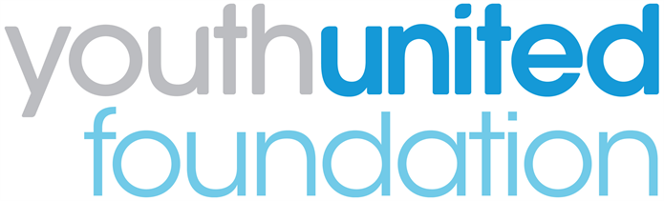

Youth United Panel 2019: Application Guide

Please read these notes carefully before filling in your application.

1. What is the Youth United Panel?
The Youth United Panel aims to give young adults aged 14-24 a voice on the future of uniformed youth services. The Panel enables young adults with experience of uniformed groups to work together with those from other groups and provide their views to decision-makers at the national level.
The Youth United Panel is being recruited by Leaders Unlocked and delivered by Youth United Foundation as a part of its ongoing research and consultation work with its network members across the country.

2. Who can join?
We are seeking to recruit 11 individuals to become Youth United Panel members from January to December 2019. These Panel members can live anywhere in England. Each member will represent one of the uniformed youth groups.

We are looking for applications from 14-24 year olds who are currently members of uniformed youth groups including Air Cadets; Army Cadet Force; The Boys' Brigade; Fire Cadets; The Girls' Brigade England & Wales; Girlguiding; Jewish Lads' and Girls' Brigade; The Scout Association; Sea Cadets; St John Ambulance and Volunteer Police Cadets.

We are seeking young adults who can be ‘experts through their experience’ of uniformed youth services.

We are looking for people who are team players and willing to get involved with all the project’s activities. We are also very keen to make sure that the Youth Panel engages a diverse range of young adults from different backgrounds and geographical areas.

3. If I join, what will I have to do?
Between January and December 2019, Youth United Panel members will be asked to:
- Take part in Youth United Panel events: You will participate in 4-6 Panel events throughout the year. The first of these will be held on January 19th 2019 in London. Over the course of the year, these events will be held in different locations across the country. At these events, you will come together as a team to share your views and experiences, work with experts and decision-makers and support our key areas of research.
- Be involved in peer research: You will be actively engaged in conducting peer research relating to loneliness, mental health and well being. You will be working with our research partner and gathering the views of other young people in uniformed groups. Our research partners will host two residential sessions with you so that the Youth Panel can develop and lead on this exciting project. The first session will coincide with the February half term and will be focused on the Panel developing ideas for the research, learning how to collect information from other young people in uniformed youth groups. The second residential, planned for the Easter holidays, with dates to be agreed with the Panel, will be a chance for you all to report back on your findings. Our researchers will provide you all with full support and fun training to enable you to deliver an amazing project.
If you are worried that a ‘research project’ might not be for you, please don’t be put off from applying – the residentials, which will be led by an fantastic and experienced team, will provide you with all the support you will need.
4. What will I get from being part of the Panel?

As a Panel member, you will have the opportunity to:

- Discuss issues with decision-makers: You will meet key officials from government and other agencies and help them to understand what young adults in your peer group think about uniformed youth services.
- Develop your skills and experience: You will gain valuable skills and experience, which you will be able to use for your CV and applications to further or higher education or employment.
- Represent the views of other young people: You will give a voice to young people in your area by helping them to get their views heard.
- Meet new people: You will meet a diverse range of young people from across England, and work alongside professionals from different organisations.

Travel expenses will be covered for attendance at all meetings and lunch will be provided.

5. How do I apply?

Please fill in the enclosed application form and email it to:
alev@leaders-unlocked.org by Friday 30th November 2018.

- Section 1: If you are under 18, you must also fill out the section regarding your Parent /Guardian /Carer. All members under the age of 18 will be asked to bring along a signed consent form to the first event.

- Privacy: Your privacy is really important to us. By filling in the Youth United Foundation Panel application form, you are consenting to Leaders Unlocked and Youth United Foundation using your personal information to keep in touch with you over the course of the project. If your application is not successful, or you decide to withdraw your application, we will delete your personal data from our files. If you want to withdraw your consent at any time you can contact the Data Protection officer at info@leaders-unlocked.org and if you would like to see our full Privacy Notice you can do so here http://leaders-unlocked.org/wp-content/uploads/2018/05/Leaders-Unlocked-Privacy-Notice-May-2018-1.pdf

6. What happens next?

Please email your completed application form to:
alev@leaders-unlocked.org by Friday 30th November 2018.

After the deadline, we will carry out Skype interviews with shortlisted applicants. All applicants will be informed of the outcome by the 19th December.

We look forward to receiving to receiving your application!

