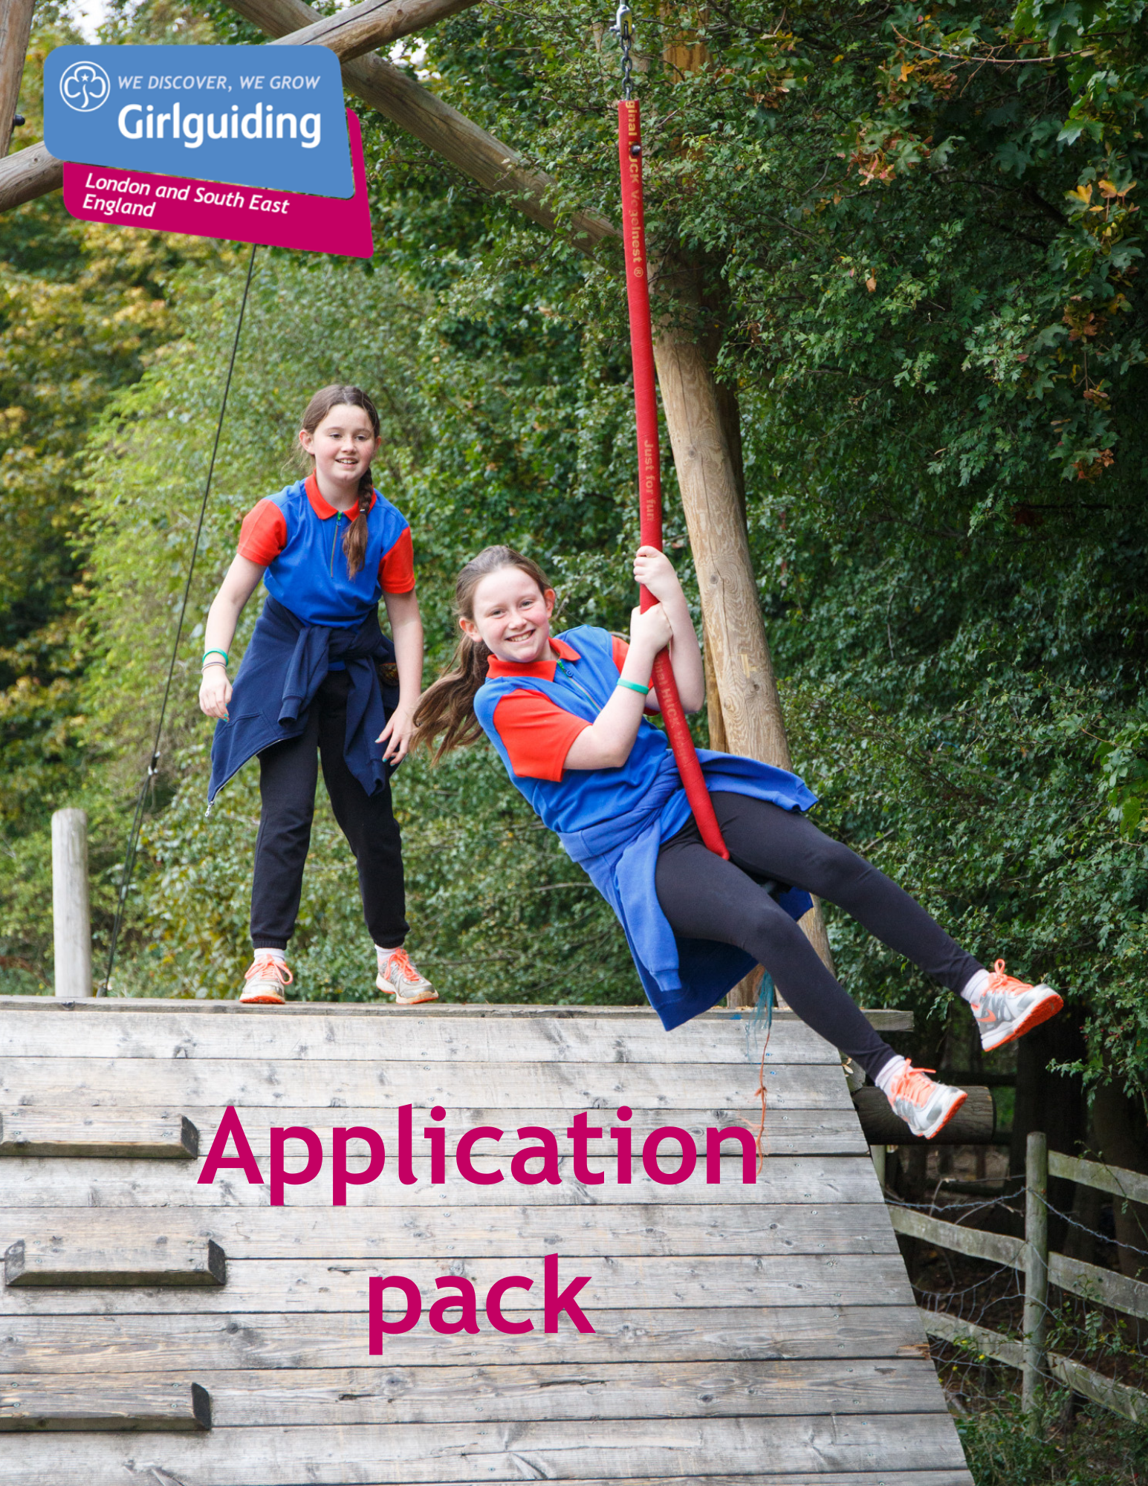

Girlguiding LaSER

Commissioner Training Coordinator
Voluntary

About Girlguiding

Girlguiding is the leading charity for girls and young women in the UK, with over a half a million members, including over 100,000 trained volunteer adult leaders and supporters.

We are active in every part of the UK, giving girls and young women a space where they can be themselves, have fun, build brilliant friendships, gain valuable life skills and make a positive difference to their lives and their communities. We build girls’ confidence and raise their aspirations. We give them the chance to discover their full potential and encourage them to be a powerful force for good.

Young members are grouped by age into five sections: Rainbows, Brownies, Guides and Rangers.

Girlguiding is independently operated through three countries; Scotland, Wales and Northern Ireland and six English regions; North West England, North East England, Midlands, Anglia, South West England and London & South East England, each having their own headquarters employing core staff.

About Girlguiding LaSER

The role of Girlguiding London and South East England (LaSER) is to deliver the business of Girlguiding in London and South East England Region.

We offer girls and young women quality girl-led guiding opportunities, presenting challenge and adventure, which develop their potential and enable them to make a positive contribution to their community and beyond. We also provide training and support for adult volunteers.

The LaSER headquarters is based in Wandsworth Common.

Purpose of the Role

Understanding the training needs of Division and District Commissioners and working with the trainers to deliver impactful events.

Role Responsibilities

- Coordinate appropriate trainings for Commissioners across the region in liaison with the Training Coordinator. This role includes all Commissioners including designates and County Commissioner mentors
- Advise on matters relating to Commissioner training
- Develop a strong working relationship with the office staff team.
- Provide regular reports to the Learning & Development Lead volunteer
- Receive and act on information received through National and region channels in consultation with the Learning & Development Lead Volunteer as appropriate
- Advise and liaise with County Commissioner mentors and arrange support meetings as appropriate. This includes facilitating the County Commissioner Mentor forum
- Participate or take the lead on any other relevant initiative identified in consultation with the Learning & Development Lead Volunteer
- Attend Learning & Development meetings
- Promote Girlguiding LaSER and Girlguiding generally.
- Portray a positive image of Girlguiding LaSER and Girlguiding.
- Support on budgets related to Commissioner training

Person Specification

Criteria | Essential / Desirable | Evidence
Skills
Good organisational skills | Essential | Application/Interview
Good oral and written skills | Essential | Application/Interview
Ability to work as part of a team | Essential | Application/Interview
Ability to work with information of a confidential or sensitive nature | Essential | Application/Interview
Experience
To be a Girlguiding trainer or have relevant strong experience | Essential | Application/Interview
Experience of the Commissioner role | Essential | Application/Interview
Good overall knowledge of specialism | Essential | Application/Interview
Behaviours
Be creative and enthusiastic; open to new ideas and willing to find better ways of working | Desirable | Application/Interview
Be committed to on-going personal development | Desirable | Application/Interview
Confidence to have challenging conversations. | Desirable | Application/Interview
Ability to motivate and inspire adult volunteers | Desirable | Application/Interview

Employment Details

Voluntary (Appointment for initial 3 year term, extension for 2 years maximum)

There is no remuneration for this post, but all reasonable expenses will be reimbursed.

How to Apply

Closing date: Thursday 13 August at 9 am.
Interview date: TBC
How to apply: Please email recruitment@girlguidinglaser.org.uk with a small statement on why you’re interested and what you could bring to the role.

If you have any questions about the role please direct them to Fiona Jackson, Learning & Development Lead Volunteer at recruitment@girlguidinglaser.org.uk

