BRONZE OR SILVER DofE RECORD OF COMPLETION FORM
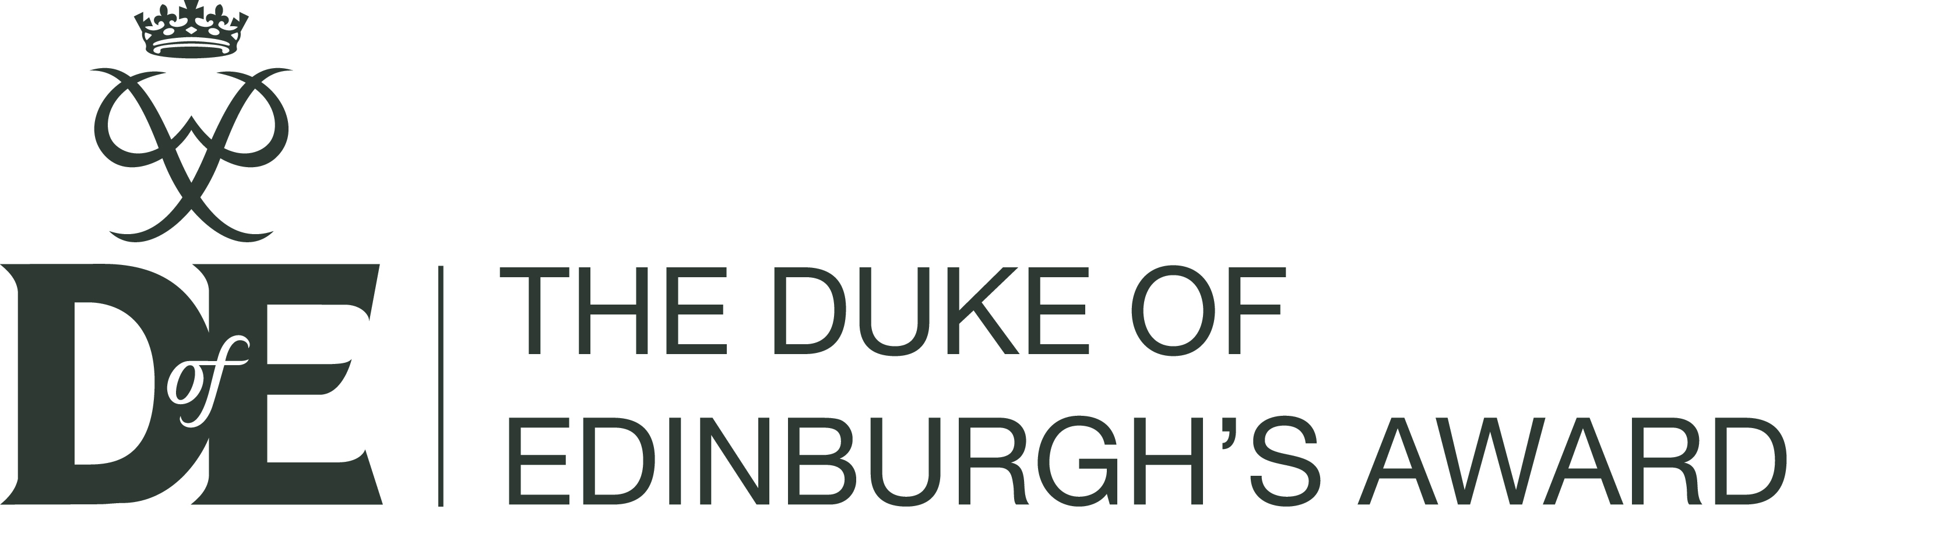

This form is to be used by County DofE Advisers when someone completed their Bronze or Silver DofE (Please note there is a different process for Gold DofEs).

- Approves the award on eDofE. The award is automatically sent to the Region Adviser for verification.
- Once the Award is verified this appears in County Adviser’s “Manage participants” list.
- Complete this form.
- Email the form to Katie Sturgess at Region Office katies@girlguidinglaser.org.uk
(Forms can be posted to Katie Sturgess, 3 Jaggard Way, Wandsworth Common, London SW12 8SG. If posting we recommend you keep a copy until the certificate and badge are received).

Jen Friend, Region DofE Adviser: dofe@girlguidinglaser.org.uk

Name of DofE participant
GO Number eDofE Number
DofE Group County
Level completed (please delete as appropriate) Bronze DofE Silver DofE
Date award was varied on eDofE
Details of who to send badge and certificate to (Normally this would be the County Adviser or Leader).
Name
Address

Date and Signature of County DofE Adviser

