#FestivalOfLaSER
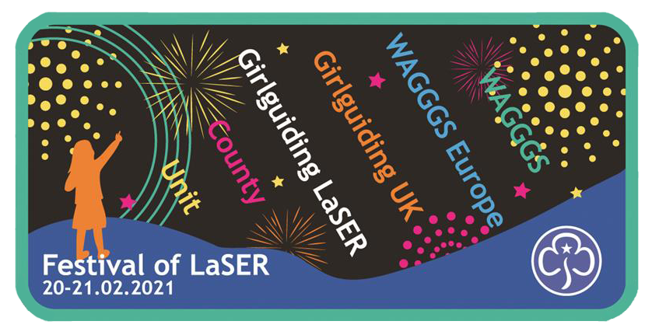

Join us on the weekend of 20&21 February
from 10am to 4.00pm both days

Festival of LaSER

Get ready for a virtual weekend of fun, celebration, activities and more. Subscribe to our region YouTube channel and get ready for a great time.

Our unit will be...

Let your unit know here what special activities you will be doing around Festival of LaSER here.

Subscribe to LaSER’s YouTube channel here.

