**Guidelines for Nominations of a Regional or National Girlguiding Award**

The process:

You believe that a member of Girlguiding is deserving of an award

Consider which award to apply for. Information is available on the Girlguiding LaSER website and in the Guiding Manual.

Complete a Proposed Award Application. List the people who would write a citation for the nominee, (you do not need to include any citations with the application at this point).

The Region Awards Committee will review the application and advise you on the most appropriate award to apply for.

These may be presented at a local level. See the Girlguiding Thanks and Recognition page in the Guiding Manual and talk to your local Commissioner.

Approach your County Awards team.

Send the completed nomination, marked confidential, to the County Awards team.

Has she previously received a Thanks Badge, good Service Brooch or County Award?

Following the guidance notes, complete the appropriate application and collect citations in support of the application.

Yes

No

Do you know which award you wish to apply for?

Yes

No

The Region Awards Committee will decide whether to recommend to the Chief Commissioner that an award be made (in the case of a Region award) or that it be submitted to the National committee in the case of a National Girlguiding award. The Chair of the committee will then feedback the decision of the committee to the nominator, along with any recommendations for further action if appropriate.

**What makes a strong application?**

A little bit of planning in advance can make putting together an award application much more straightforward. It will help you identify who you can approach to help you, and what aspects of the nominee’s guiding to highlight. This will also ensure that your application gives a good, well rounded picture of the nominee, which makes for a much stronger nomination.

Remember, the people considering the application (both at Region and Nationally) will only be able to judge on what they read so make sure your application is comprehensive and provides insight into a range of different aspects of the nominee’s guiding.

Your application and letters of support should show:

* What makes this person **stand out** above the many other people who give a solid commitment to Guiding week on week – what makes them really **special**?
* What **impacts** their achievements have made on girls or adult volunteers
* It is good to give practical examples of **service**, **innovation** etc. and what the person has **achieved** as an individual. Examples of her **character**, **personality**, **enthusiasm**, **qualities** and what makes her ‘**shine’** are all very helpful. Talk about her **leadership skills**, **achievements**, **dedication** over and above the usual, the **impact** she has had, her **commitment**, her **influence**. What makes her outstanding and sets her apart.

**Approaching people for letters of support**

You should ensure that everyone you approach for a letter of support (also known as a citation) knows this process is confidential and that no member of this person’s family should be aware of the application. For this reason it is not appropriate to nominate a member of your own family. It is useful for you to have thought specifically about what aspect of guiding you want your different supporters to describe. It will be easier for them to write a citation if they know exactly what it needs to include. A help sheet is available for you to give to the people you approach to help them know how to write a strong letter.

**How many letters of support will I need?**

For a Chief Commissioner’s Award nomination the committee would expect between six and eight citations, (though one may contain contributions from more than one person). For a National Girlguiding award you may include up to eight nominations. More important than the number of citations, though, is the quality of their contents.

**Who should I approach?**

Think about different people who can show the different aspects of the nominee’s guiding life. Who might have been personally affected/inspired by something the nominee has done? Contributions from young people often tell a good story. Nominations do not always need to be in form of a letter. You could give some Guiding postcards to a group of young people and ask them to make some comments.

A quick exercise like the one below can help you identify who you could approach for letters of support and what you would like their letter to include.

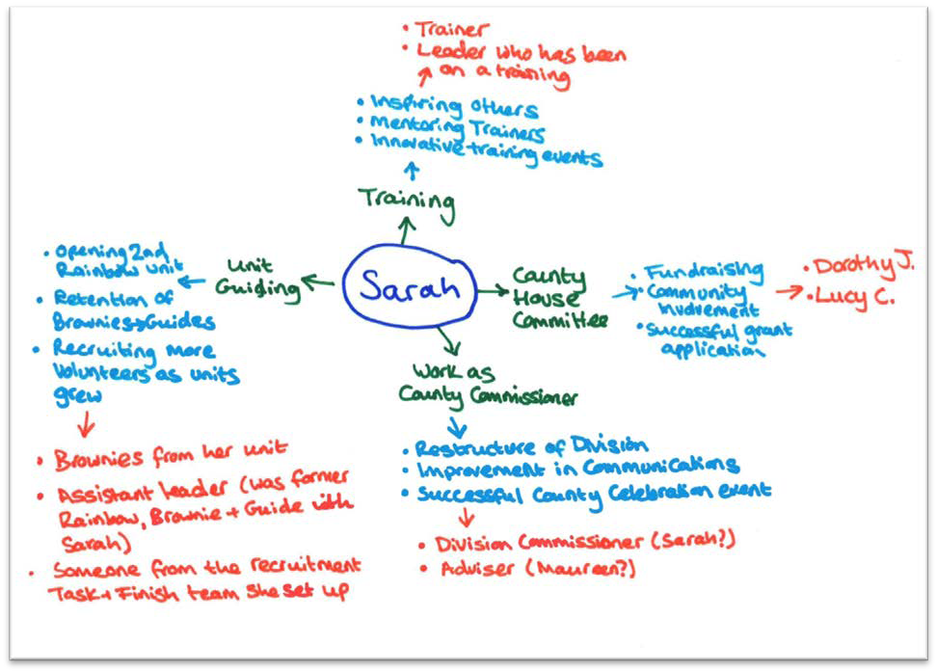

## Letters of support should:

* Be typed, signed and include name, role, position of supported and be dated.
* Not contain too much duplicated information. You may want to approach more people than the number of nominations you need, but if they cover very similar things you may wish to consider either choosing the strongest letter, or combining comments from more than one person into one citation (crediting each person with what they said).
* Be persuasive – encourage the supporter to talk enthusiastically but specifically about what the nominee has done.
* The supporter should describe as far as possible within their requested remit:
  + The capacity in which they know the nominee and for how long they have known them.
  + The personal attributes that make them stand out from others. Where possible they should give examples to build up a picture describing their special character and personality.
  + Their guiding service, giving examples of outstanding achievements.
  + Their influence on others – leadership skills, innovative ideas and inspirational work in supporting adults and girls.
  + Any specific event or project where the nominee has made an outstanding contribution.
  + Any other aspects of the nominee’s life which are relevant to this award.
  + If appropriate to the nomination a letter could be an eyewitness account of an incident, or provide full and detailed information, including details of any medical condition or emergency situation if relevant and possible (this is mainly in the case of a Guiding Star application). Patient confidentiality must be respected and medical evidence must pass only between the Country/Region Medical Adviser and the nominee’s doctor.

## Award Application Checklist:

* Find out what the deadline is for the next Region awards meeting.
* Identify who you could approach to provide a letter of support/citation (think of more people than the letters you hope to receive as you may not get a response from everyone).
* Prepare a letter/email to these people, saying why you are nominating this person, why you are specifically asking them to help and listing a couple of the things you would like them to include in their letter. Send the Guidelines for writing a letter of support for Girlguiding awards help sheet with your request. Give them a date by which you would like to receive their response.
* Completed the Chief Commissioner’s Award Application; or Application for a Girlguiding Discretionary Award form and ensure that this form is signed by all supporting the application. **It must be signed by the County Commissioner\***. Please note, it is not appropriate to submit an application for an award for a family member. (*If the nomination is for the County Commissioner, another member of the County Executive may sign it)
* Ensure you have included the appropriate number of citations to send with the application
* Check each citation is named and dated
* Send the complete application by post (marked confidential) to Diane Barnes, Girlguiding London & South East England, 3 Jaggard Way, Wandsworth Common, London, SW12 8SG or by email to [dianeb@girlguidinglaser.org.uk](mailto:dianeb@girlguidinglaser.org.uk) If submitting an award by post it is a good idea to also send an email to Marie so she knows it is on its way and can acknowledge safe receipt. If completing and returning the form electronically please copy all supporters into the email. This will be considered an electronic signature.
* If the award has been successful, arrange a time with the your County Commissioner/ the Chief Commissioner for this to be presented.
* Advise the Region Manager when the award presentation has taken place by returning the confirmation slip to the Region office. She will then update Go! to show the