Ideas for Girlguiding units to use re Ukraine with their young members
Many leaders aren’t sure how to cover the topic of the situation in Ukraine in their units and through crowd sourcing we wanted to compile a list of ideas that other leaders have tried, as a source of ideas for all leaders.
Please add anything you have done or hear other units have done. Thank you
Idea | More detail
Planting Sunflowers | Sunflower is the national flower of the Ukraine , so plant some outside or in pots.  Decorate the pots with words of peace
Sunflower seeds – spreading message of peace | Make little envelops of sunflower seeds with an appropriate message on the front for our unit members to take and give to other families
Fundraise | Donate money to the WAGGGS emergency appeal World Association of Girl Guides and Girl Scouts (wagggs.org)
Craft - Make pin/ribbon badges | Make ribbon badges for the unit to wear to show solidarity
Craft - Window decorations | 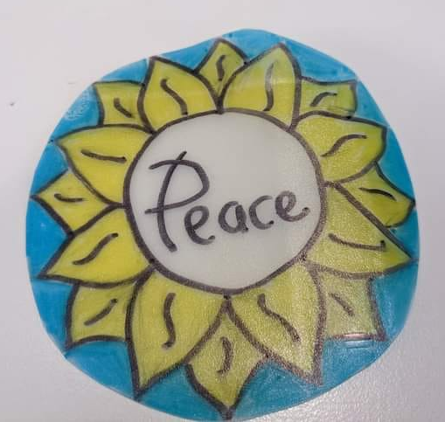  Made with plastic milk bottles and sharpies  Could have the outline underneath to trace or for younger members pre drawn and they colour in
Collect Donations of useful items | Find a local group who is collecting first and find out what they need then encourage donations from families.  This may change over the year ahead – as displaced people settle in new countries – so could be something to do a few times but finding out first what the recipients need
Create bags for women/ young girls | 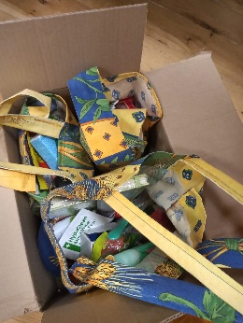  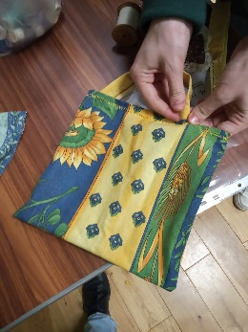  Create bags of items young women would find useful full of items they might need (washing, sanitary, pens/notebooks, long lasting sweets, messages of kindness, socks etc)
Advocate for Peace | Show your solidarity with Guides and Scouts, and all of the families – and children – affected by the war in Ukraine. Highlight how it is girls and women who are often disproportionately affected in armed conflicts and that government and civil society responses must take account of this.  Write to a political representative such as a Member of Parliament to express your concern and sadness about the war in Ukraine and armed conflict around the world – sharing your personal view and your own voice is most powerful.
WAGGGS/WOSM ‘In the shoes of migrants’ board game | Play this board game on refugees (produced by a joint WAGGGS and WOSM Europe Region working group)  In the shoes of the Migrants (wagggs.org)
Language | Learn how to say some welcoming phrases in Ukrainian
Craft – Make cards | Create little cards with nice messages of welcome or peace to be share with families who have had to leave their homes.  These might be useful now but also in a few months time for local guiding and scouting organisation in countries where Ukrainian families settle (here or in Europe).
Social Media – what is the truth | Have a discussion to explore with the young members about how you need to verify information that comes out on social media or the news – and not just believe it as it is on one of the platform.  Discuss too how information is controlled by media platforms including within Russia so many people in Russia do not have access to the same news we do and are being told a different set of information by their government and media about the situation  (If anyone knows of a resource that helps do that please do add here)  https://www.theguardian.com/world/2022/feb/26/propaganda-filters-truth-ukraine-war-russian-media  https://www.bbc.co.uk/news/world-60525350 << Good source of trustworthy information  https://www.bbc.co.uk/newsround/60568631 << How to spot misleading stories online about Ukraine crisis  https://www.bbc.co.uk/newsround/60662417 << Ukraine: Why has Russia invaded and what's happening there?
 | https://www.bbc.co.uk/newsround/13865002 << Advice if you're upset by the news

