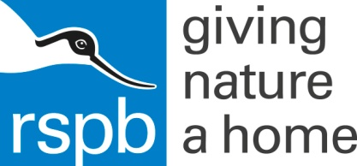
RSPB and Girlguiding LaSER partnership - Bird Survey form
The Sussex Ornithological Society really appreciates the data you have recorded today. Please fill out this form with the birds you have spotted, all the data will be added into the national data base. Send it back with your evaluation form to the RSPB.
Name of observer
Name of Group
Site name
Site address
Grid Reference (1k)
Date of observation |  |  |  |  |  | Time
Start time |  |  |  |  |  | Finish time
Weather
Wind description using the Beaufort scale | calm | Light air | Light breeze | Gentle breeze |  |  | Moderate breeze | Fresh breeze |  |  | Strong breeze | Near gale | Gale | storm
Bird species |  |  |  |  | Number
Blackbird
Blue tit
Black-headed gull
Buzzard
Carrion crow
Cuckoo
Feral pigeon
Green Woodpecker
Green finch
Pied-wagtail
Great tit
Goldfinch
Heron
House martin
Herring gull
Jackdaw
Jay
Kestrel
Magpie
Robin
Red wing
Rook
Starling
Sparrow
Swift
Swallow
Wood pigeon
Other species

