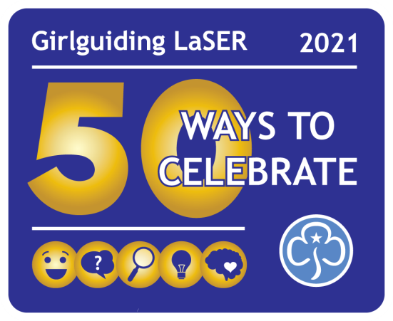**50 Ways to Celebrate - Recording Grid**

|  |  |  |  |
| --- | --- | --- | --- |
| **LAUGH** | **Date of completion** | **Short summary of activity** | **Notes** |
| **Made You Laugh** |  |  |  |
| **Improvisation Station** |  |  |  |
| **Laughter Yoga** |  |  |  |
| **Who Said That?** |  |  |  |
| **Fun songs to sing** |  |  |  |
| **Nonsense poems** |  |  |  |
| **Comedy Film Night** |  |  |  |
| **Have fun raising funds** |  |  |  |
| **Share a smile** |  |  |  |
| **Hula Hoop Squash** |  |  |  |
| **ASK** | **Date of completion** | **Short summary of activity** | **Notes** |
| **Music ask** |  |  |  |
| **Be a tour guide for the day** |  |  |  |
| **What is the Commonwealth of Nations** |  |  |  |
| **WAGGGS World Centres** |  |  |  |
| **Making connections** |  |  |  |
| **Celebrations across the region** |  |  |  |
| **Campfire classics snacks** |  |  |  |
| **Going for Gold** |  |  |  |
| **Communicate in other ways** |  |  |  |
| **Growing Up Wild Paw Print** |  |  |  |

You can record your activities in any way which works for you, but you might like to use this grid

|  |  |  |  |
| --- | --- | --- | --- |
| **SEE** | **Date of completion** | **Short summary of activity** | **Notes** |
| **Golden films** |  |  |  |
| **Golden birds** |  |  |  |
| **50p - the celebration coin** |  |  |  |
| **What's the story of the flag?** |  |  |  |
| **See history come to life** |  |  |  |
| **Around the world in an evening** |  |  |  |
| **See LaSER's famous landmarks** |  |  |  |
| **Food is science** |  |  |  |
| **Set the scene** |  |  |  |
| **Foods from around the region** |  |  |  |
| **EXPERIENCE** | **Date of completion** | **Short summary of activity** | **Notes** |
| **Celebake** |  |  |  |
| **A day in the life…70s** |  |  |  |
| **A day in the life…80s** |  |  |  |
| **A day in the life…90s** |  |  |  |
| **A day in the life…2000s** |  |  |  |
| **A day in the life…2010s** |  |  |  |
| **Geocaching treasure hunt** |  |  |  |
| **Arts and crafts from A-Z** |  |  |  |
| **The one about dancing** |  |  |  |
| **Festival of LaSER sleepover** |  |  |  |
| **REFLECT** | **Date of completion** | **Short summary of activity** | **Notes** |
| **A conversation with myself** |  |  |  |
| **Twist and turn me** |  |  |  |
| **Make change today. For our world, tomorrow** |  |  |  |
| **Story in my pocket** |  |  |  |
| **Time to be creative** |  |  |  |
| **Meditation** |  |  |  |
| **Mindfulness and storytelling** |  |  |  |
| **What is this?** |  |  |  |
| **What is this smell?** |  |  |  |
| **Reflect on reflect** |  |  |  |