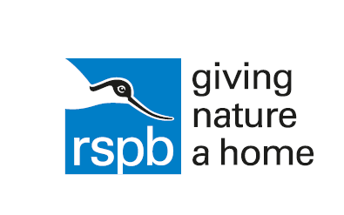
What you need to

Sounds of Spring | Can you recognise and remember the song of six bird species that are singing around you in spring and early summer? Learn the songs and then head outside to hear them for real.  Listen up for birdsong - resource sheet
Make a Nest Box | Natural places for birds to nest, like holes in trees, are getting increasingly hard to find, especially in urban areas. This activity is about building a home for birds and giving them a place to stay.  Make a nest box - resource sheet
Wild Weather | Wherever you go and whatever you do, the weather is always with you. It affects wildlife in loads of ways, and changes from season to season. Watching clouds, capturing rain, and seeing which way the wind blows is a science you know more about than you think!
Planting for Wildlife | Fill your school grounds with nature friendly plants and flowers to attract a world of amazing wildlife. This activity is about planting the right plants, flowers and shrubs to attract a variety of creatures, from butterflies and bees to seed eating birds.  mini-meadow - resource sheet  butterfly garden - resource sheet
Signs of Spring | Spring is here and whether you're in the middle of a city or a remote corner of the countryside, you can't fail to spot nature coming to life. Get outdoors where you live and see how many signs of spring you can spot  Springo! bingo - resource sheet

