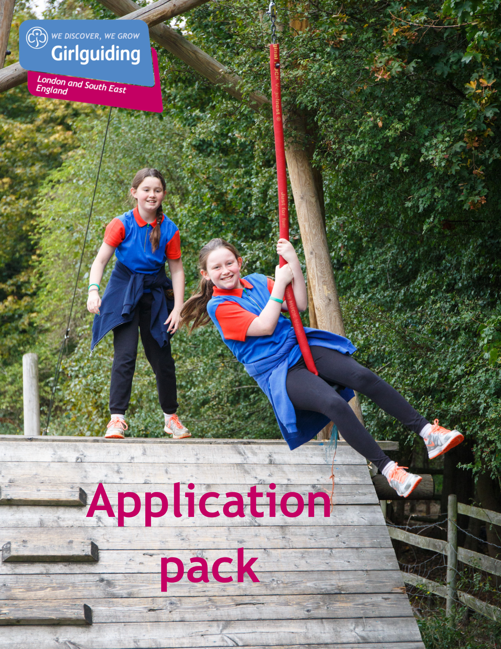

Girlguiding LaSER

Growth and Retention Officer
Part Time (14-21h per week)

About Girlguiding

Girlguiding is the leading charity for girls and young women in the UK, with over a half a million members, including over 100,000 trained volunteer adult leaders and supporters.

We are active in every part of the UK, giving girls and young women a space where they can be themselves, have fun, build brilliant friendships, gain valuable life skills and make a positive difference to their lives and their communities. We build girls’ confidence and raise their aspirations. We give them the chance to discover their full potential and encourage them to be a powerful force for good.

Young members are grouped by age into five sections: Rainbows, Brownies, Guides and Rangers.

Girlguiding is independently operated through three countries; Scotland, Wales and Northern Ireland and six English regions; North West England, North East England, Midlands Anglia, South West England and London & South East England, each having their own headquarters employing core staff.

About Girlguiding LaSER

The role of Girlguiding London and South East England (LaSER) is to deliver the business of Girlguiding in London and South East England Region.

We offer girls and young women quality girl-led guiding opportunities, presenting challenge and adventure, which develop their potential and enable them to make a positive contribution to their community and beyond. We also provide training and support for adult volunteers.

The headquarters is based in its own property at Wandsworth Common where ten staff members are employed.

Purpose of the Role

We are recruiting a Growth and Retention Coordinator to work as part of the Region Office Team, working with the region manager, marketing & communications teams, trustees and lead volunteers to take on an exciting role in our fast-paced and forward-thinking organisation.

This is a crucial time for growth and retention for us, following on from the COVID-19 pandemic. This is a fantastic opportunity for you to bring your own creativity and ideas to this role, and to really help grow Girlguiding LaSER.

The right candidate will have the opportunity to work with a wide variety of colleagues and volunteers in a collaborative and creative environment, whilst also having the autonomy to help develop and shape their role and responsibilities.

We are looking for someone with an enthusiastic and positive outlook who can bring to the role a variety of skills and experience across key areas including:

• Developing and delivering Girlguiding LaSER’s Growth and Retention strategy, in line with our business plan.
• Bringing their own ideas and creativity to the role, coming up with new and impactful ways to retain our current members and retain our reach.
• Delivering high quality, responsive support for volunteers to enable them to recruit and retain girls and volunteers.
• Influencing the integration of learning and development, marketing and communications and growth and retention into the delivery of our programme offer.

The job requires someone who can work with volunteers, manage a diverse workload and work well on their own as well as part of a small team.

Role Responsibilities

Main duties for the post:

- Deliver and develop Girlguiding LaSER’s Growth and Retention (G&R) strategy using and creating resources to ensure the greatest impact in line with LaSER’s business plan.
- Deliver high quality, appropriate and responsive support for counties to enable them to recruit and retain girls and volunteers.
- Engage and enthuse counties to evolve their ‘county growth plans’ so that they align with LaSER Region’s strategic objectives and priorities.
- Support the integration of learning and development, marketing and communications and growth and retention in the delivery of our programme offer.
- Consider and act on any other ideas that will support LaSER’s G&R goals.
Relationships:
- Establish constructive and productive working relationships with the lead volunteers, staff and volunteers.
- Agree the priorities, performance measures and reporting framework to ensure the impact of LaSER’s strategy is measured and reported upon.
- Work closely with Girlguiding’s national growth and insight team to ensure consistency across membership recruitment and retention. Represent LaSER as required and sharing best practise with other countries and regions.
- Facilitate appropriate information sharing and learning across counties so that best practice is encouraged.

Operational Delivery

- Ensure the approach of recruiting and retaining girls and volunteers across counties is in line with LaSER’s strategy, and Girlguiding’s policy and priorities, whilst providing tailored support and signposting where different approaches are required.
- Develop awareness of the G&R tools, resources and development opportunities available, and enable counties to access them.
- Implement innovative and creative approaches, and develop new resources to support counties, based on evidence of ‘what works’.
- Keep up to date with new Girlguiding resources and initiatives. Use and promote them as appropriate.
- Make recommendations for actions and share local best practice examples with the Girlguiding national team for consideration of being taken to scale.
Data management

- Assist staff and lead volunteers to analyse and interpret data, building their ability to plan effectively. Develop volunteer’s knowledge of benchmarking, analysing and evaluating information to target priorities.
- Ensure requests and enquiries from the counties are logged and analysed to identify trends and common support needs that may be best addressed through the development of new tools, templates, processes or training and development opportunities.
- Provide reports to managers, lead volunteers and trustees as directed.

Person Specification

Criteria | Essential / Desirable | Evidence
Skills & Knowledge
- Providing customer-focused service in a timely and supportive manner | Essential | Application & interview
- Prioritise and respond to enquiries from multiple sources | Essential | Application & interview
- Benchmarking and using outcome measurement tools to report on progress. | Essential | Application & interview
- Analysing data and presenting it in an easily digestible way | Essential | Application & interview
- Positively engaging and enthusing volunteers | Desirable | Application & interview
- Intermediate knowledge of CRM systems, and MS Office including programmes such as Word, PowerPoint, Excel | Essential | Application & interview
- Deep understanding of Girlguiding structure | Essential | Application & interview
Experience
- Achieving successful recruitment or retention outcomes | Desirable | Application & interview
- Engaging others to deliver action plans and achieve KPIs | Essential | Application & interview
- Planning and delivering successful projects | Essential | Application & interview
- Achieving successful outcomes with recruitment or retention | Essential | Application & interview
- Strategic planning | Essential | Application & interview
- Volunteer recruitment | Desirable | Application & interview
Behaviours
- Excellent written and verbal communication skills | Essential | Application & interview
- Manage a varied workload | Essential | Application & interview
- Attention to detail | Essential | Application & interview
- Able to identify opportunities to create a positive change and make them a reality. | Essential | Application & interview

Employment Details

Reports to | Marketing & Communications Manager
Salary | £22,413 – £25,622 pro rata (depending on experience)
Working Hours | 14-21 hours per week  These can be spread flexibly across the week.
Location | We are committed to ensuring that our staff have a good work-life balance and offer a flexible working environment.

This job will require some out of hours working including evenings and weekends to meet Girlguiding LaSER’s business needs and where deemed necessary. Time off in lieu will be given.
Willingness to be flexible with working pattern is essential.

How to Apply

Closing date: 24 May at 9 am.
Interview date: TBC
How to apply: Email your application form to recruitment@girlguidinglaser.org.uk

