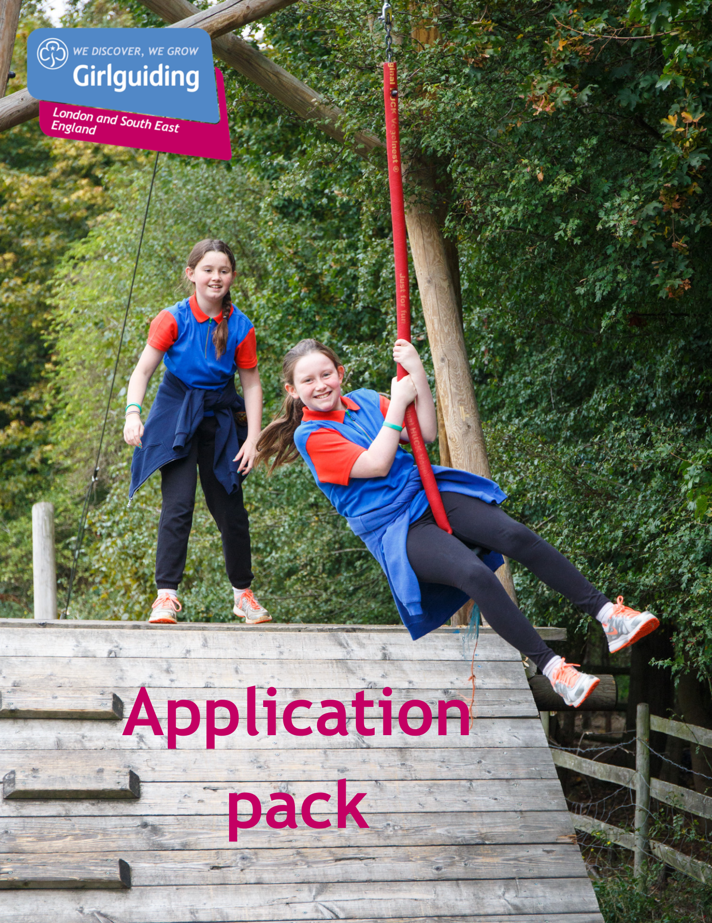

Girlguiding LaSER

Learning, Development & Events Administrator

About Girlguiding

Girlguiding is the leading charity for girls and young women in the UK, with over a half a million members, including over 100,000 trained volunteer adult leaders and supporters.

We are active in every part of the UK, giving girls and young women a space where they can be themselves, have fun, build brilliant friendships, gain valuable life skills and make a positive difference to their lives and their communities. We build girls’ confidence and raise their aspirations. We give them the chance to discover their full potential and encourage them to be a powerful force for good.

Young members are grouped by age into four sections; Rainbows, Brownies, Guides and Rangers and for young women aged 18-30 we have Inspire.

Girlguiding is independently operated through three countries; Scotland, Wales and Northern Ireland and six English regions; North West England, North East England, Midlands, Anglia, South West England and London & South East England, each having their own headquarters employing core staff.

About Girlguiding LaSER

The role of Girlguiding London and South East England (LaSER) is to deliver the business of Girlguiding in London and South East England Region.

We offer girls and young women quality girl-led guiding opportunities, presenting challenge and adventure, which develop their potential and enable them to make a positive contribution to their community and beyond. We also provide training and support for adult volunteers.

The LaSER headquarters is based in Wandsworth Common.

Purpose of the Role

The role of Girlguiding London and South East England (LaSER) is to deliver the business of Girlguiding in London and South East England Region.
As a member of the staff team, provide administrative support to deliver the Girlguiding LaSER Strategic Plan, working closely with the Girlguiding LaSER volunteers in the following key areas:
- Learning and development trainers team including A Safe Space
- Learning and development including Sections, DofE, Queens Guide, Peer Education
- Girlguiding LaSER events
Managing Membership System GO database and actioning enquiries

Role Responsibilities

- Communicate and establish excellent working relationships with other staff, Girlguiding LaSER appointment holders, and other volunteers.
- Support staff and volunteers in relation to the Girlguiding LaSER trainer team.
- Support the essential training coordinator to ensure that our members are compliant e.g. in our safeguarding training A Safe Space.
- Manage the DofE Award, which includes updating databases and sending out rewards.
- Day to day administrative support of the Learning, development and events team as required, including phone and email enquiries via high volume inboxes.
- Support the implementation of the new learning and development platform for region training.
- Carry out tasks ranging from large scale projects through to everyday administration as directed by the Learning, development, and events manager.
- Attend events and meetings when necessary (this will involve occasional out of hours working for which time off in lieu will be given)
- Take minutes at governance meetings as required
- Maintain the Girlguiding membership database for provision of reports and data analysis as required.
- Monitor the Girlguiding membership database to ensure that information is accurate and regularly updated, providing information and reports to colleagues as needed.
- Liaise with county commissioners and other internal contacts to keep records up to date.
- Maintain a knowledge of current Girlguiding resources and initiatives.
- Maintain confidentiality in all relevant matters, including storage and release of data and images, relating to Girlguiding LaSER.
- Implement the region’s Health and Safety policy, and to ensure that best practices in Health and Safety are followed.
- Work as part of a team to ensure that Girlguiding LaSER priorities are achieved in a timely fashion.
- Carry out such other duties not detailed above to ensure that administration functions efficiently and effectively.

Person Specification

Criteria | Essential / Desirable | Evidence
Skills
Excellent numeracy, verbal skills including telephone manner | Essential | Application and interview
Excellent written communication skills including minute taking and preparation of papers | Essential | Application and interview
Ability to work on own initiative | Essential | Application and interview
Ability to organise own time/workload and achieve deadlines | Essential | Application and interview
Excellent word processing and IT skills, including knowledge of a range of software packages such as Microsoft Office and Zoom. | Essential | Application and interview
Monitoring of budgets. | Desirable | Application and interview
A knowledge of Girlguiding and a commitment to its statement of purpose | Desirable | Application and interview
Experience
Proven ability in administration and office procedures | Essential | Application and interview
Proven experience of handling confidential data appropriately | Essential | Application and interview
Working effectively as part of a team | Essential | Application and interview
Successful project planning and management | Desirable | Application and interview
Proven ability in events management | Desirable | Application and interview
Behaviours
Conscientious, reliable, flexible. | Essential | Application and interview
Strong positive focus on customer care | Essential | Application and interview
To be able to respect confidentiality | Essential | Application and interview

Employment Details

Salary | £20,505 - £23,471 including London weighting and depending upon experience.
Reports to | Learning, development, and events manager
Working Hours | 35 hours per week  We are committed to ensuring that our staff have a good work-life balance and offer a flexible working environment.
Location | Girlguiding LaSER Region Office  3 Jaggard Way, Wandsworth Common, London SW12 8SG

This job will require some out of hours working including evenings and weekends to meet Girlguiding LaSER’s business needs and where deemed necessary. Time off in lieu will be given.
Willingness to be flexible with working pattern is essential.

How to Apply

Closing date: 3 September at 9 am.
Interview date: 14 September
How to apply: You can download the application form here. Please note only shortlisted candidates will be contacted.

