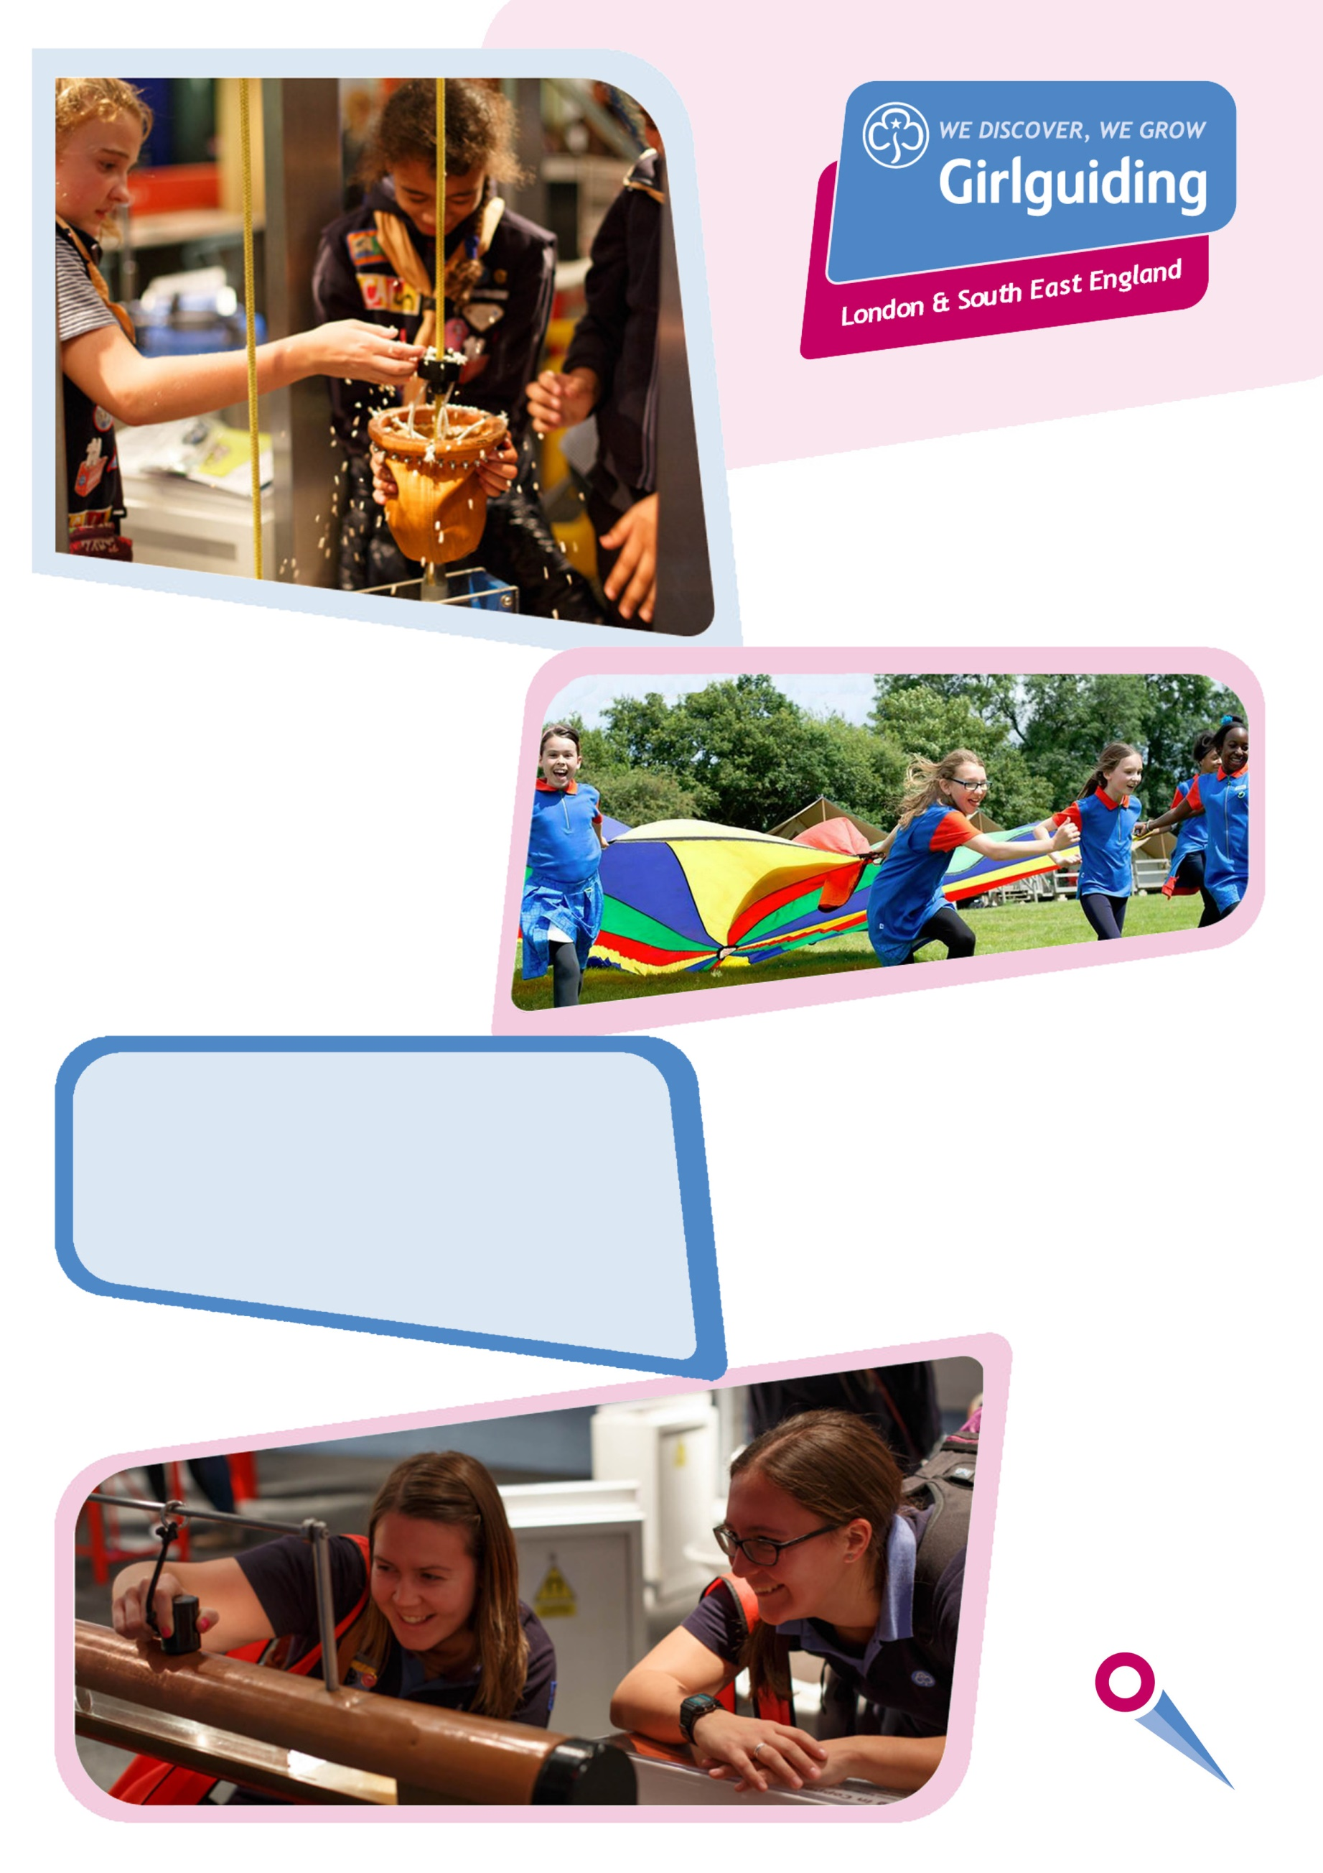
Learning, Development & Events Administrator
Recruitment Pack

Learning, Development & Events Administrator
Recruitment Pack
Girlguiding

Girlguiding is the leading charity for girls and young women in the UK, with over a half a million members, including over 100,000 trained volunteer adult leaders and supporters.

We are active in every part of the UK, giving girls and young women a space where they can be themselves, have fun, build brilliant friendships, gain valuable life skills and make a positive difference to their lives and their communities. We build girls’ confidence and raise their aspirations. We give them the chance to discover their full potential and encourage them to be a powerful force for good.

Young members are grouped by age into five sections: Rainbows, Brownies, Guides, and Rangers.

Girlguiding is independently operated through three countries; Scotland, Wales and Northern Ireland and six English regions; North West England, North East England, Midlands, Anglia, South West England and London & South East England, each having their own headquarters employing core staff.

Girlguiding is an operating name of The Guide Association which is incorporated/governed by Royal Charter and a registered charity (number 306016).

Girlguiding London and South East England

Girlguiding London & South East England (Girlguiding LaSER) consists of 19 counties covering Greater London, Surrey, Sussex, Kent and part of Essex and has a membership of over 73,000. Sally Christmas, Chief Commissioner and her deputy Liz Smith lead the region.

We offer members the opportunity for adventures and fun – through weekly meetings, camps, holidays or trips. We listen constantly to our young members so that we can evolve and adapt to ensure we are relevant to today’s girls.

Girlguiding LaSER offers girls and young women quality girl-led guiding opportunities, presenting challenge and adventure, which develop their potential and enable them to make a positive contribution to their community and beyond. We also provide training and support for adult volunteers

The headquarters is based in its own property at Wandsworth Common where ten staff members are employed. In addition to this property the region operates two campsites.

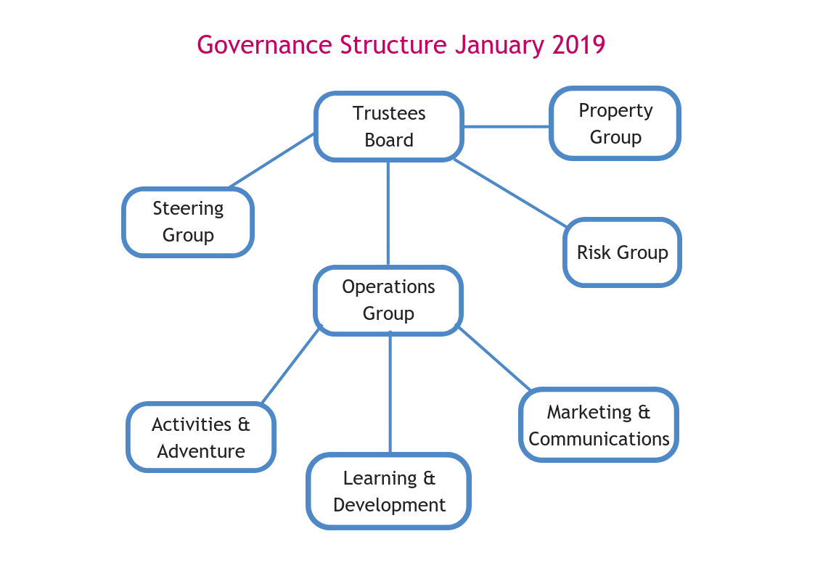

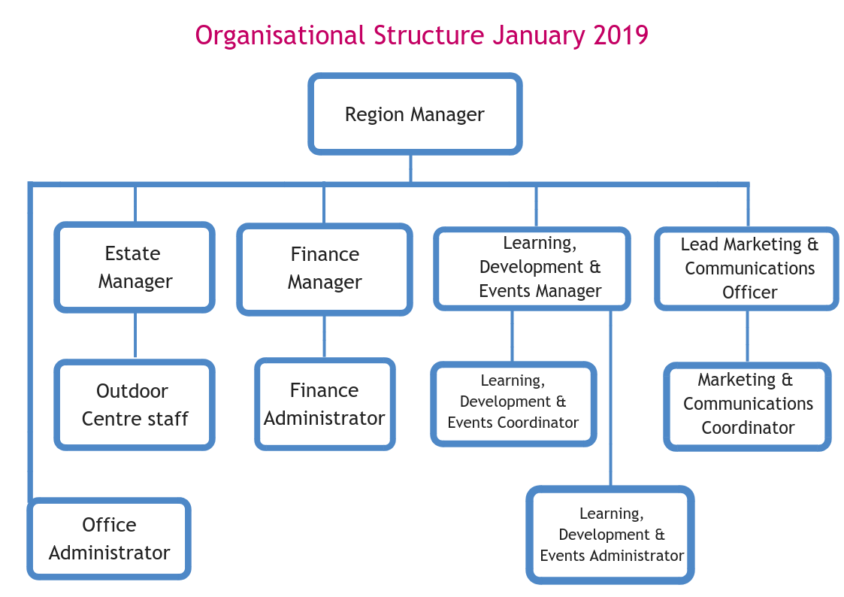

Job Description
Learning, Development & Events Administrator

Girlguiding London and South East England (LaSER)
Main Purpose and Scope of the Job
The role of Girlguiding London and South East England (LaSER) is to deliver the business of Girlguiding in London and South East England region.
As a member of the staff team, provide administrative support to deliver the Girlguiding LaSER Strategic Plan, working closely with the Girlguiding LaSER volunteers in the following key areas:
- Learning & Development Trainers team
- Learning & Development including awards
- Girlguiding LaSER events
- Managing Membership System GO database and actioning enquiries
Position in Organisation
Reports to: Learning, Development and Events Manager
Duties and Key Responsibilities
Communicates and establishes excellent working relationships, with other staff, Girlguiding LaSER appointment holders and other volunteers.
To manage and support staff and volunteers in relation to the Girlguiding LaSER Trainer team.
As directed by the Learning, Development & Events Manager, carries out tasks ranging from large scale projects through to everyday administration.
Manage the awards including Duke of Edinburgh (DofE) and Queen’s Guide Award which includes updating databases and sending out rewards.
Carries out the administration of Starting New Unit Grants (SNUG) and Residential Event Notice (REN).
Works as part of a team to ensure that Girlguiding LaSER priorities are achieved in a timely fashion.
Attends events when necessary (this will involve occasional out of hours working for which time off in lieu will be given).
Taking minutes at governance meetings as required.
Maintains the Girlguiding membership database for provision of reports and data analysis as required.
Monitors the GO database to ensure that information is accurate and regularly updated, providing information as needed.
As directed by the Learning, Development & Events Manager or Region Manager, liaises with Girlguiding regarding the Memberships systems and any relating issues including DBS checks.
Liaising with County Commissioners and other internal contacts to keep records up to date including the County Constitutions.
Maintains a knowledge of current Girlguiding resources and initiatives and resources.
Keeps confidential all relevant matters, including storage and release of data and images, relating to Girlguiding LaSER.
Implements the region’s Health & Safety policy, and to ensure that best practices in Health & Safety are followed.
Day to day administrative support of the Learning, Development and Events Team as required including phone enquiries, administration & info email.
Carries out such other duties not detailed above to ensure that administration functions efficiently and effectively.

A = Application Form, I = Interview, T = Test
Person Specification
Requirements | Criteria
Experience | Proven ability in administration and office procedures | Essential | A/I
Experience | Successful project planning and management | Desirable | A/I
Experience | Proven ability to manage data | Essential | A/I
Experience | Proven experience of handling confidential data appropriately | Essential | A/I
Experience | Ability to manage a high volume of enquiries | Essential | A/I
Experience | Ability to manage a high volume of tasks | Essential | A/I
Experience | Working effectively as part of a team | Essential | A/I
Knowledge and Skills | Excellent verbal skills including telephone manner | Essential | A/I
Knowledge and Skills | Excellent written communication skills (including letter writing and preparation of papers) | Essential | A/T
Knowledge and Skills | Excellent word processing and IT skills, including knowledge of a range of software packages | Essential | A/T
Knowledge and Skills | Ability to organise own time/workload and achieve deadlines | Essential | A/T
Personal Attributes | Conscientious, reliable | Essential | A/I
Personal Attributes | Strong positive focus on customer care | Essential | A/I
Personal Attributes | To be able to respect confidentiality | Essential | A/I
Personal Attributes | A knowledge of Girlguiding and a commitment to its statement of purpose | Desirable | A/I
Revised May 2019

This job will require some out of hours working including evenings and weekends to meet LaSER’s business needs and where deemed necessary. Time off in lieu will be given.
Willingness to be flexible with working pattern is essential.

Salary | £20,505 - £23,471 including London weighting and depending upon experience.
Reports to | Learning, Development and Events Manager
Working Hours | 35 hours per week  We are committed to ensuring that our staff have a good work-life balance and offer a flexible working environment.
Location | Girlguiding LaSER Region Office  3 Jaggard Way, Wandsworth Common, London SW12 8SG

Learning, Development and Events Administrator Recruitment Process
Information for Candidates
Timeline
Closing date for applications | 2 September 2019 9am
Interviews | TBC
Applications – email to | recruitment@girlguidinglaser.org.uk
Interviews
Interviews will be held at Girlguiding LaSER region office
3 Jaggard Way, Wandsworth Common, SW12 8SG
The office is 2 minutes’ walk from Wandsworth Common Station.
We are unable to offer parking facilities.

