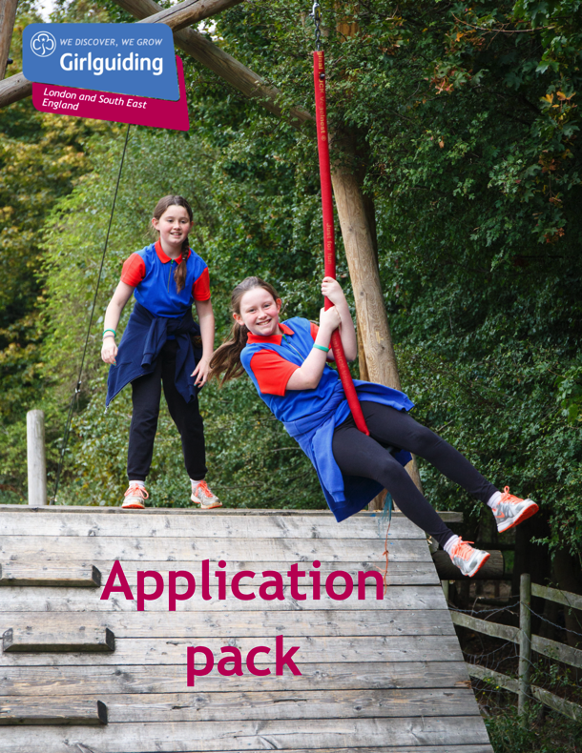

Girlguiding LaSER

Duke of Edinburgh Advisor
Voluntary

About Girlguiding

Girlguiding is the leading charity for girls and young women in the UK, with over a half a million members, including over 100,000 trained volunteer adult leaders and supporters.

We are active in every part of the UK, giving girls and young women a space where they can be themselves, have fun, build brilliant friendships, gain valuable life skills and make a positive difference to their lives and their communities. We build girls’ confidence and raise their aspirations. We give them the chance to discover their full potential and encourage them to be a powerful force for good.

Young members are grouped by age into five sections: Rainbows, Brownies, Guides and Rangers.

Girlguiding is independently operated through three countries; Scotland, Wales and Northern Ireland and six English regions; North West England, North East England, Midlands, Anglia, South West England and London & South East England, each having their own headquarters employing core staff.

About Girlguiding LaSER

The role of Girlguiding London and South East England (LaSER) is to deliver the business of Girlguiding in London and South East England Region.

We offer girls and young women quality girl-led guiding opportunities, presenting challenge and adventure, which develop their potential and enable them to make a positive contribution to their community and beyond. We also provide training and support for adult volunteers.

The LaSER headquarters is based in Wandsworth Common.

Purpose of the Role

The region supports girls undertaking their DofE awards, and leaders who make this possible for them in a number of ways. This role would have oversight of the whole award within London and South East England and would be the point of contact with Girlguiding nationally and DofE. This includes the expedition which although only one of the sections of the award it is the one where support from the region is essential for many girls / young women to be able to complete their award.
This role could be filled by one candidate or as a job share with one person leading on the expedition part of the post. The exact division of responsibilities and tasks would be discussed by the potential post holders and the region team and mutually agreed.

Role Responsibilities

- Liaison with the region office over the process of registering new participants and new units offering DofE.
- Ensuring new units get support either from county adviser or region adviser.
- Ensuring participants with no unit leader get support though linking with another unit, through county or from region adviser
- Ensuring programme of trainings for leaders is offered annually:
- Introduction to DofE
- Expedition Supervisors’ Training
- Expedition Assessors Accreditation Training
- Verify all submitted Bronze & Silver awards – or agree appropriately trained and qualified person to be the region verifier
- Ensuring appropriate standards are maintained at each level of the award across the region. Where necessary give support to leaders in what activities are appropriate for each section, and what needs to be included in assessors’ reports.
- Arranging for certificates, badges and personal letters of congratulation to go to all bronze and silver award holders. Arranging for badges and personal letters of congratulation to go to all gold award holders.
- Where possible, ensuring offers of places at Gold presentations are offered to leaders who have had significant input into those gaining their gold awards (liaise with HQ).
- Ensuring regular communication with all county advisers and leaders running DofE to pass on information from GG HQ & DofE HQ.
- Ensuring channels of communication are kept open in both directions with GG DofE link (Jen Symes) and county advisers / leaders.
- Attending annual meeting of region / country DofE advisers.
- Hold annual meeting for county advisers & leaders running DofE
- Maintain up to date list of expedition assessors.
- Liaise with region office around organisation of events – including completion of event proposal forms.
- Liaise with HQ about fund applications and spending.
- Where appropriate liaise with County Commissioners over DofE in their counties.
- Monitor activities in counties through eDofE – including numbers of awards gained.
DofE expeditions
- Providing advice and support on the practicalities of the expedition section to all advisers / leaders. For example this would include help on submission of green forms, guidance / advice on route choices, walking qualifications needed for routes planned, suggestions of assessors, suggestion of campsites, supporting girls with particular needs, approving applications for exceptions, or forwarding to HQ for approval.
- Checking green forms and routes for all routes in wild country, and from all county advisers.
- Approving applications to be accredited expedition assessors or to renew the accreditation before forwarding to HQ.
- Run region expedition programme:
- Expedition training weekend for Bronze, Silver & Gold
- Expedition practices for Bronze, Silver & Gold
- Assessed expeditions for Bronze, Silver & Gold.
- Each of these events must be agreed in advance with the region through the event proposal form, dates fixed, accommodation booked (through the office), information made available to be put on website for booking, information and forms sent out to participants.
- Ensure suitably qualified and experienced leaders are in place for the number of groups attending each event to fulfil the role of instructor, supervisor, and assessor. Close liaison with these leaders to ensure they are fully briefed on their roles.
- In addition, for the practice and assessed expeditions information must go out to participants on their route planning. Routes then need to be checked on eDofE, collated, and submitted to expedition network for approval, together with green form.
- Equipment must be sourced for those who cannot provide their own (primarily tents & stoves).
- eDofE records need to be updated for those participating in the LaSER open expeditions.

Person Specification

Criteria | Essential / Desirable | Evidence
Skills
To be able to work as part of a team alongside other advisers | Essential | Application and interview
To have strong communication skills | Essential | Application and interview
Desire to motivate and inspire girls and young women from a broad range of backgrounds. | Essential | Application and interview
Ability to motivate and inspire adult volunteers and young adult members | Essential | Application and interview
Experience
Experience working with DofE Award programme | Essential | Application
Behaviours
Have a passion for the DofE Award and encouraging members to participate | Essential
Have an open and approachable manner | Desirable
Be creative and enthusiastic; open to new ideas and willing to find better ways of working | Desirable
Be committed to on-going personal development | Desirable

Employment Details

Working hours: Voluntary

There is no remuneration for this post, but all reasonable expenses will be reimbursed.

How to Apply

Closing date: Friday 23 July at 9 am.
Interview date: TBC
How to apply: Please email recruitment@girlguidinglaser.org.uk with a small statement on why you’re interested and what you could bring to the role.

If you have any questions about the role please direct them to Fiona Jackson, Learning & Development Lead Volunteer at recruitment@girlguidinglaser.org.uk

