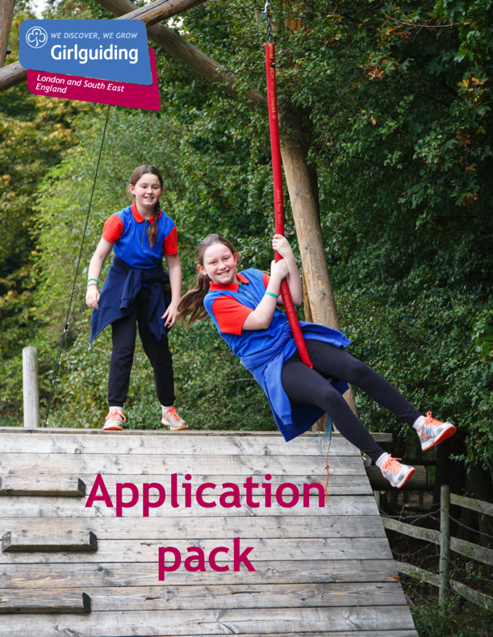

Girlguiding LaSER

Region Peer Educator Coordinator
Voluntary

About Girlguiding

Girlguiding is the leading charity for girls and young women in the UK, with over a half a million members, including over 100,000 trained volunteer adult leaders and supporters.

We are active in every part of the UK, giving girls and young women a space where they can be themselves, have fun, build brilliant friendships, gain valuable life skills and make a positive difference to their lives and their communities. We build girls’ confidence and raise their aspirations. We give them the chance to discover their full potential and encourage them to be a powerful force for good.

Young members are grouped by age into five sections: Rainbows, Brownies, Guides and Rangers.

Girlguiding is independently operated through three countries; Scotland, Wales and Northern Ireland and six English regions; North West England, North East England, Midlands, Anglia, South West England and London & South East England, each having their own headquarters employing core staff.

About Girlguiding LaSER

The role of Girlguiding London and South East England (LaSER) is to deliver the business of Girlguiding in London and South East England Region.

We offer girls and young women quality girl-led guiding opportunities, presenting challenge and adventure, which develop their potential and enable them to make a positive contribution to their community and beyond. We also provide training and support for adult volunteers.

The LaSER headquarters is based in Wandsworth Common.

Purpose of the Role

A coordinator is a designated point of contact for a particular element of the guiding programme. Coordinators are responsible for ensuring that their area of specialism is organised and all relevant people are aware of their roles within that area. They will attend meetings and have regular contact with county coordinators, region staff and lead volunteers and teams at other levels.

Girlguiding’s peer education programme empowers 14- to 25-year-old members to deliver activity based sessions to Brownies, Guides and Rangers on topics which are important to their lives. These sessions are informative, fun and interactive, providing young members with the space to explore subjects in a safe, girl-led environment. As a peer education coordinator you will work collaboratively to promote and support peer education in the region, organising appropriate training and coordinating relevant administrative processes in order to support the smooth running of the programme. You should be enthusiastic about how girls and young women can benefit from delivering and participating in peer education.

Role Responsibilities

The list below outlines the general responsibilities of a Region Peer Education Coordinator, but you will be working within a wider team and responsibilities may vary.

- Support County Coordinators by providing relevant information and updates, and help with queries and issues.
- Identify and develop potential Peer Educator Trainers to deliver peer education trainings within the Region.
- Be enthusiastic and encouraging to those taking on Peer Education roles; give administrative and practical support as well as help with any issues.
- Provide ongoing administrative support to the region by coordinating and organising matters related to peer education, often by email.
- Develop and implement a local plan for peer education in the context of the national operation of the programme.
- Demonstrate a working knowledge of and enthusiasm for your specialism.
- Support County Peer Educators to provide a safe girl-only space where girls and young women can discover their full potential through all areas of the programme.
- Attend level-specific meetings and events as appropriate.
- Ensure there are adequate training opportunities within your specific area of expertise.
- Administer any applicable training or qualifications in your area of responsibility.
- Keep up to date with new resources and programme initiatives, and use them as appropriate.
- Complete relevant training for the role and ensure the wider team’s skills are up to date.
- Manage a budget, liaise with the region team as necessary.
- Raise awareness of peer education throughout the area, using appropriate communication channels to promote trainings, topics and sessions.
- Gather feedback on the effectiveness of sessions, monitor whether peer education is put into practice, and use the Learning to Lead resource.
- If no County Coordinator is in post, directly support Peer Educators by signposting them towards resources and trainings.
- Develop and maintain clear communications with region staff, relevant advisers, coordinators, trainers and lead volunteers.

Person Specification

Criteria | Essential / Desirable | Evidence
Skills
While these skills and abilities are not essential when starting, they should be developed as part of the role.
Ability to work as part of a team | Essential | Application and interview
Excellent communication skills | Essential | Application and interview
Desire to motivate and inspire girls and young women from a broad range of backgrounds. | Essential | Application and interview
Ability to motivate and inspire adult volunteers and young adult members | Essential | Application and interview
Experience
Experience working with Girlguiding’s peer education programme. | Desirable | Application
Behaviours
An open and approachable manner | Desirable | Application and interview
Creative and enthusiastic | Desirable | Application and interview
A commitment to ongoing personal development | Desirable | Application and interview
Passionate about the aims of peer education and the benefits of peer support for young women. | Essential | Application and interview

Employment Details

Girlguiding welcomes volunteers of all backgrounds, ages, cultures, faiths and abilities. We are flexible, and volunteering can be arranged to fit around a busy lifestyle. Please note this is a volunteer role; this role description does not form part of any contract of employment.

How to Apply

Closing date: 23rd July 2021 at 12:00noon
Interview date: TBC
How to apply: Please email recruitment@girlguidinglaser.org.uk with a small note on why you are interested and what you could bring to the role.

