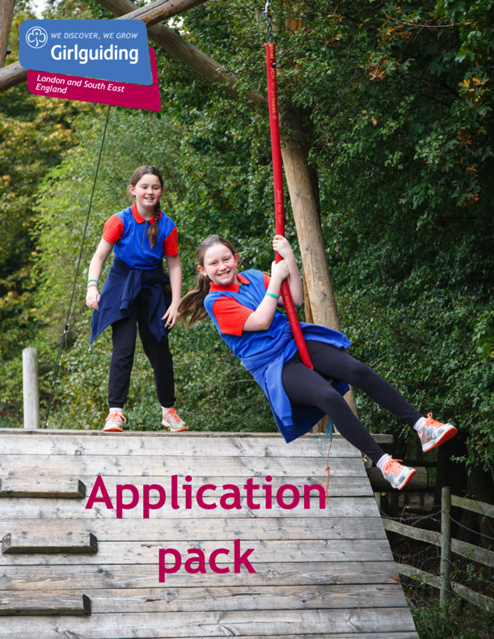

Girlguiding LaSER

Queen’s Guide Award Coordinator
Voluntary

About Girlguiding

Girlguiding is the leading charity for girls and young women in the UK, with over a half a million members, including over 100,000 trained volunteer adult leaders and supporters.

We are active in every part of the UK, giving girls and young women a space where they can be themselves, have fun, build brilliant friendships, gain valuable life skills and make a positive difference to their lives and their communities. We build girls’ confidence and raise their aspirations. We give them the chance to discover their full potential and encourage them to be a powerful force for good.

Young members are grouped by age into five sections: Rainbows, Brownies, Guides and Rangers.

Girlguiding is independently operated through three countries; Scotland, Wales and Northern Ireland and six English regions; North West England, North East England, Midlands, Anglia, South West England and London & South East England, each having their own headquarters employing core staff.

About Girlguiding LaSER

The role of Girlguiding London and South East England (LaSER) is to deliver the business of Girlguiding in London and South East England Region.

We offer girls and young women quality girl-led guiding opportunities, presenting challenge and adventure, which develop their potential and enable them to make a positive contribution to their community and beyond. We also provide training and support for adult volunteers.

The LaSER headquarters is based in Wandsworth Common.

Purpose of the Role

The Region Queen’s Guide Coordinator supports Queens Guide Co-ordinators, Mentors and Participants from across the Region to increase engagement and ensure a consistent and effective approach.

They will promote and support Queen’s Guide Award participation, organising relevant meetings and coordinating the administration processes in order to support the smooth running of the programme.

They will be enthusiastic about how young women can benefit from involvement in the Queen’s Guide Award, inspire members to participate and encourage Leaders and Commissioners to promote and support the opportunities.

Role Responsibilities

- Demonstrate a working knowledge of and enthusiasm for the Queen’s Guide Award syllabus and requirements
- Provide on-going administrative support to the Region by coordinating and organising matters related to the Queen’s Guide Award, often by email.
- To chair, when relevant, meetings of Queen’s Guide Award Co-ordinators and/or Mentors from across the Region to share best practice, address issues and provide a support and information network
- To hold information meetings for existing and interested participants and oversee an on-line support network
- Represent the Region at National Queen’s Guide Award meetings and other meetings and events as appropriate
- Keep up to date with new resources and programme initiatives, and use them as appropriate
- Raise awareness of the Queen’s Guide Award throughout the area, using appropriate communication channels to promote trainings, topics and sessions
- Develop and maintain clear communications with region staff, relevant advisers, coordinators and lead volunteers.

Person Specification

Criteria | Essential / Desirable | Evidence
Skills
While these skills and abilities are not essential when starting, they should be developed as part of the role.
To be able to work as part of a team alongside other advisers | Essential
To have strong communication skills | Essential
Experience
Have experience of the Queen’s Guide Award programme | Essential
Behaviours
Have an open and approachable manner | Desirable
Be creative and enthusiastic; open to new ideas and willing to find better ways of working | Desirable
Have a passion for the Queen’s Guide Award and encouraging members to participate | Essential
Be committed to on-going personal development | Desirable

Employment Details

Girlguiding welcomes volunteers of all backgrounds, ages, cultures, faiths and abilities. We are flexible, and volunteering can be arranged to fit around a busy lifestyle. Please note this is a volunteer role; this role description does not form part of any contract of employment.

How to Apply

Closing date: 23rd July 2021 at 12:00noon
Interview date: TBC
How to apply: Please email recruitment@girlguidinglaser.org.uk with a small note on why you are interested and what you could bring to the role.

