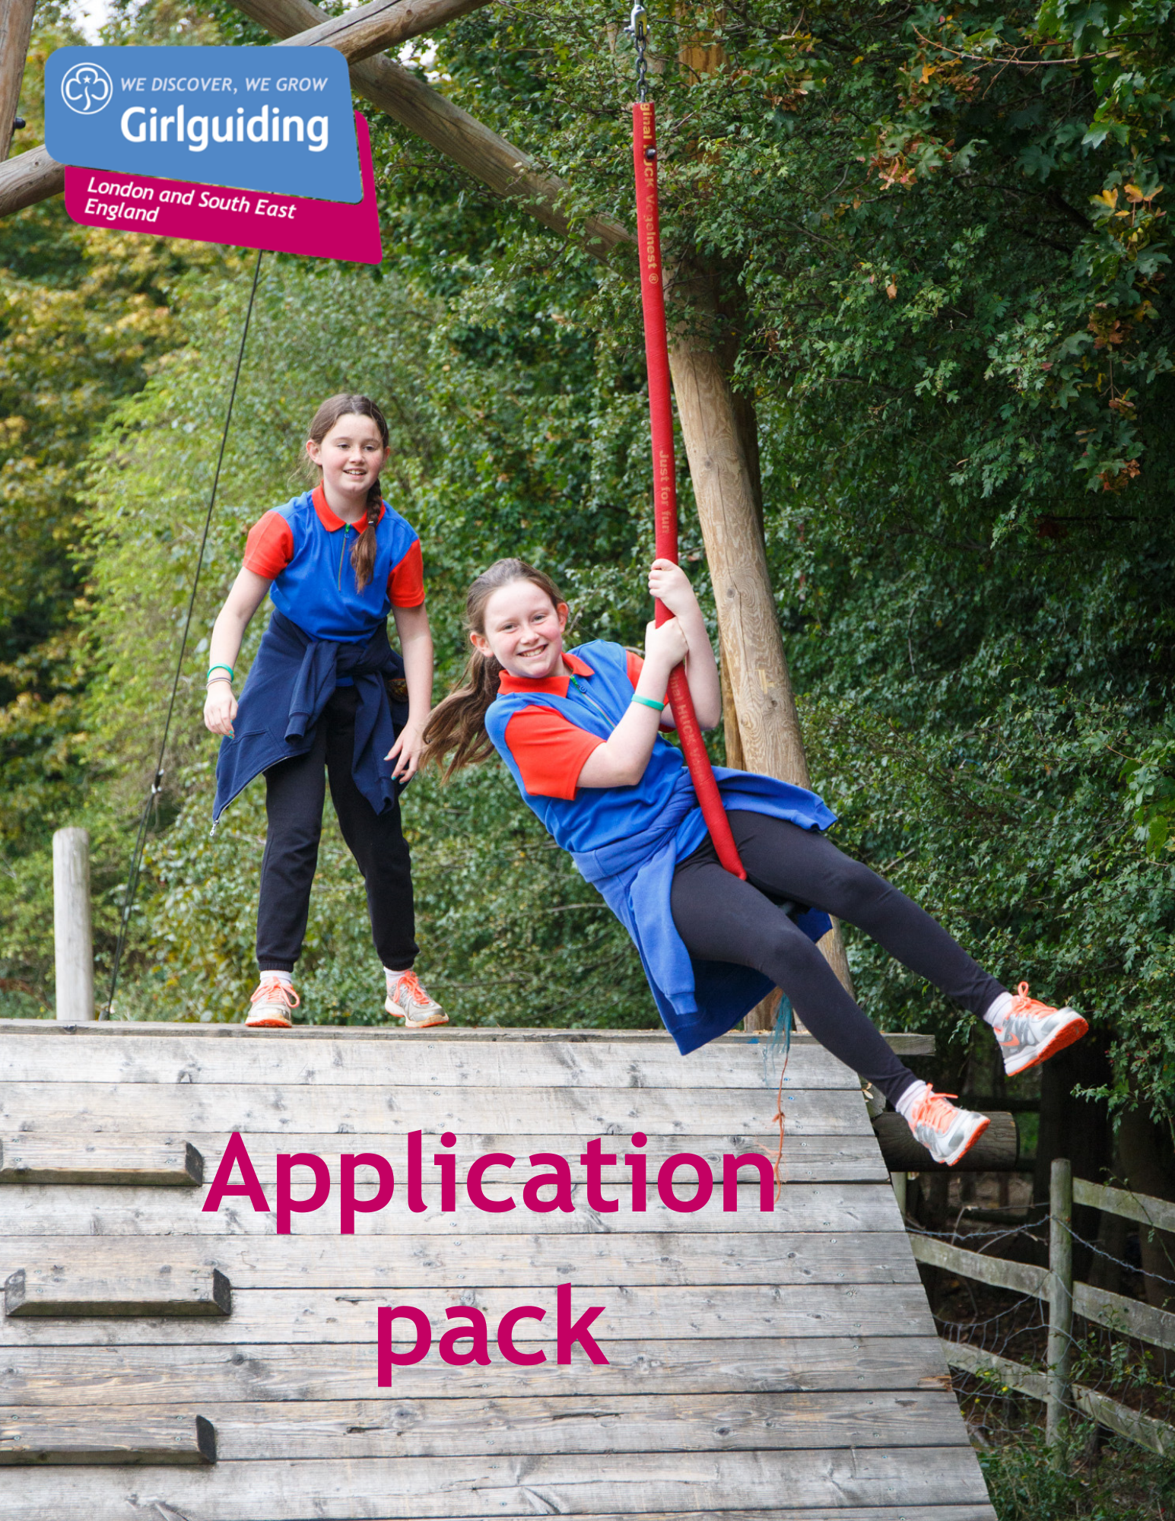

Girlguiding LaSER

TQ Coordinator

Voluntary

About Girlguiding

Girlguiding is the leading charity for girls and young women in the UK, with over a half a million members, including over 100,000 trained volunteer adult leaders and supporters.

We are active in every part of the UK, giving girls and young women a space where they can be themselves, have fun, build brilliant friendships, gain valuable life skills and make a positive difference to their lives and their communities. We build girls’ confidence and raise their aspirations. We give them the chance to discover their full potential and encourage them to be a powerful force for good.

Young members are grouped by age into five sections: Rainbows, Brownies, Guides and Rangers.

Girlguiding is independently operated through three countries; Scotland, Wales and Northern Ireland and six English regions; North West England, North East England, Midlands, Anglia, South West England and London & South East England, each having their own headquarters employing core staff.

About Girlguiding LaSER

The role of Girlguiding London and South East England (LaSER) is to deliver the business of Girlguiding in London and South East England Region.

We offer girls and young women quality girl-led guiding opportunities, presenting challenge and adventure, which develop their potential and enable them to make a positive contribution to their community and beyond. We also provide training and support for adult volunteers.

The LaSER headquarters is based in Wandsworth Common.

Purpose of the Role

Working with Trainers in training, supporting them through the TQ (Trainer Qualification) and ensuring quality mentoring as well as co-ordinating Tutor support.

Role Responsibilities

- Work with the BAT coordinator to ensure a smooth process for BAT’s as they move to becoming prospective trainers
- Recruit and maintain an active group of tutors/reviewers, including opportunities for knowledge/skills updates & development
- Contribute to the national picture, both at meetings and on slack
- Work with the Training Coordinator and Commissioner Training Coordinator to ensure prospective trainers have meaningful opportunities to train
- Work with the Peer Education Coordinator to encourage peer educators to move into training
- Allocate Tutors to their Prospective Trainers & allocate a Reviewer to each Partnership.
- Ensure that Reviewers and Tutors receive the necessary training and support to carry out their role.
- Identify the learning needs of Prospective Trainers, Tutors and Reviewers by reviewing their Personal Development Plans at least annually and arranging training as required, either locally or nationally.
- Liaise with the Leadership & Development Team at Girlguiding, and attend meetings representing Girlguiding LaSER.
- Design and Implement quality assurance systems for the Region, which ensure that the National Objectives are met, and consistency and standardisation are achieved
- Ensure all the necessary records are maintained.
- Attend region Learning & Development meetings.
- Receive and act on information received through National & Region channels in consultation with Learning & Development Lead Volunteer as appropriate.
- Provide regular reports to the Learning & Development Lead Volunteer as required
- Promote Girlguiding LaSER and Girlguiding generally.
- Portray a positive image of Girlguiding LaSER and Girlguiding.
- Support on budgets related to Trainers Qualification

Person Specification

Criteria | Essential / Desirable | Evidence
Skills
Good organisational skills | Essential | Application/Interview
Good oral and written skills | Essential | Application/Interview
Ability to work as part of a team | Essential | Application/Interview
Ability to work with information of a confidential or sensitive nature | Essential | Application/Interview
Experience
To be a Girlguiding trainer or have relevant strong experience | Essential | Application/Interview
Good overall knowledge of specialism | Essential | Application/Interview
Behaviours
Be creative and enthusiastic; open to new ideas and willing to find better ways of working | Desirable | Application/Interview
Be committed to on-going personal development | Desirable | Application/Interview
Confidence to have challenging conversations. | Desirable | Application/Interview
Ability to motivate and inspire adult volunteers | Desirable | Application/Interview

Employment Details

Voluntary (Appointment for initial 3 year term, extension for 2 years maximum)

There is no remuneration for this post, but all reasonable expenses will be reimbursed.

How to Apply

Closing date: Thursday 13 August at 9 am.
Interview date: TBC
How to apply: Please email recruitment@girlguidinglaser.org.uk with a small statement on why you’re interested and what you could bring to the role.

If you have any questions about the role please direct them to Fiona Jackson, Learning & Development Lead Volunteer at recruitment@girlguidinglaser.org.uk

