Thailand LaSER 2019 Expedition
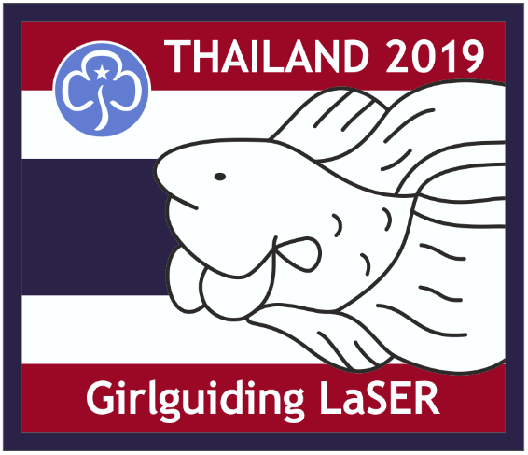

Activity Pack

Sawatdi Kha
Hello
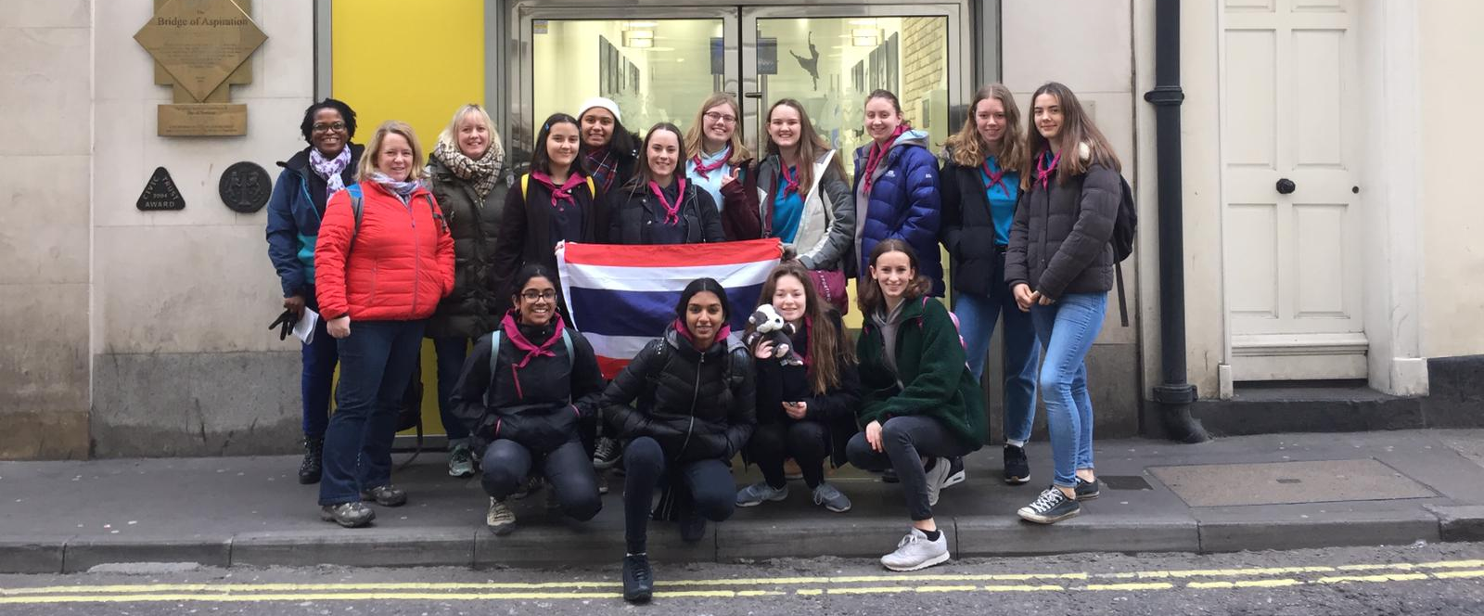
L-R Back Lorraine, Deborah, Jennie, Anna, Katelyn, Betsy, Emily, Lexie, Isobel, Abi, Evelyn
L-R Front Sruti, Anjali, Lizzie, Lucy
We are a group of twelve Guides and Rangers and three leaders from London & South East Region who have been selected to take part in an international expedition to Thailand in August 2019.

For three weeks we will be working to complete service projects in Singburi and the Northern Hill Tribes of Chiang Rai. Over the three weeks, we will be working in renovation and construction to upgrade the living standards for all the children in two temple schools. The temple school provide housing, food and education to children who may be without family members to care for them.

The programme focuses on construction and renovation work that improves the façade and structures of the school. Additionally, we will be teaching English, doing sports coaching and creative activities to help educate the children about hygiene, the environment and other important issues.
We have come up with different activities to help the girls to learn a bit about Thailand just as we are doing. All information which could be needed is given after the activity title. To help you work out which activities are suitable for your section, we have put the relevant trefoil beside each activity for the sections we think can take part in the activity. Some of these activities younger girls might find a bit harder, so we recommend that Rainbows and Brownies might need more help.

Contents

Learn some basic Thai 1
Thailand Quiz 4
Thai Flag 6
Memory game 7
Delicious Thai Food 8
Origami fish 11
Breaking barriers 12
Kites 13
Basic Thai games 14
Painted umbrellas 15
Prayer flags 16
The Floating Lantern Festival 17
Make your own Lantern Boat! 18
“The Toong” - Thai Lanna long flag 19
Thailand LaSER 2019 Badge Order Form 20

Learn some basic Thai
It is always important to know some of the basic dialect of the country. In Thailand they speak the Thai language.
Have a go at learning some basic Thai which we might need to use.
English | Pronunciation | Thai symbol
Hello | Sawatdee | สวัสดี
How are you | Sabai dee ru | เป็นอย่างไรบ้าง
I am fine | Pom Sabai dee (man)  Chan Sabai dee (women) | แสดงการขอบคุณ
What is your name? | khun cheu arai?
My name is.. | Pom chue (man)  Chan chue (woman)
Have fun | Mee sanuk | มีความสุข
Thank you | Khob Khun krap (man)  Khob Khun ka (woman)
Yes | Chai | ครับ; ค่ะ; จ้ะ; ขอรับ
No | Mai Chai | ไม่
(you/I) can | dai | สามารถ
Can not | Mai dai | ไม่ได้
Never mind | Mai pen rai | จิตใจ; ความคิด; สติปัญญา
I cannot speak Thai | Pood Thai mai dai | ฉันไม่สามารถพูดภาษาไทย
Do you understand? | Kow jai mai | คุณเข้าใจไหม
I do not understand | Mai kow jai | ฉันไม่เข้าใจ
I’m from England | Chan mak | ฉันมาจากอังกฤษ
How much? | Nee Tao Rai? | เท่าไหร่?
Expensive | Pang | แพง
Very Expensive | Pang mak | แพง อย่างมากมาย
Can you give a little discount? | Lot noi dai mai?
Cheap | took | ถูก
Water | naam | น้ำลายไหล
Good luck | Chok dee | โชคชะตา
Airport | Sanaam bin | อากาศ; บรรยากาศ
Hot | ron | ร้อน
Cold | nao | เย็น
Toilet | Hong naam | ห้องน้ำ
Ice | Naam keng | น้ำแข็ง
Small - not much - a little bit | Nit noi | เล็ก
Large | yai | ใหญ่โต
1 | neung | ๑
2 | Song | ๒
3 | Sam | ๓
4 | See | ๔
5 | haa | ๕
6 | hok | ๖
7 | jet | ๗
8 | paed | ๘
9 | gow | ๙
10 | sip | ๑๐
11 | Sip-et | ๑๑
12 | Sip-song | ๑๒
20 | Yee sip | ๒๐
30 | Saam sip | ๓๐
100 | roi/loi | ๑๐๐

Thailand Quiz

It is good to know about the country to which you are traveling to. Have a go at some of these questions to find out more about Thailand.

- What was Thailand called until the 1930s?
  - Land of a thousand smiles
  - The Lotus Land
  - Siam
  - Cambodia

- What is the capital of Thailand?
  - Myanmar
  - Laos
  - Chiang Mai
  - Bangkok

- What colours make up the flag of Thailand?
  - Red and blue
  - Red, blue and black
  - Blue and black
  - Red, blue and white

- Which of these bugs is considered a delicacy in Thailand?
  - Cricket
  - House fly
  - Mosquito
  - Maggots

- What is the national sport of Thailand?
  - Takraw
  - Football (soccer)
  - Muay Thai
  - Basketball

- Religion is an important part of the culture of Thailand. What religion do most citizens of Thailand practice?
  - Islam
  - Buddhism
  - Christianity
  - Hinduism

- Who are Thailand’s neighbours?
  - Cambodia, China, Japan and Malaysia
  - Cambodia, Burma, Laos and Malaysia
  - Japan, Laos, Malaysia and Korea
  - Korea, Vietnam, Cambodia and Malaysia

- Which of these animals is NOT a native animal of Thailand?
  - Green sea turtle
  - Javan rhino
  - Asian elephant
  - Red panda

Answers: 1C, 2D, 3D, 4A, 5C, 6B, 7B, 8D

Thai Flag
Using materials from around the room, make the Thai flag (below):
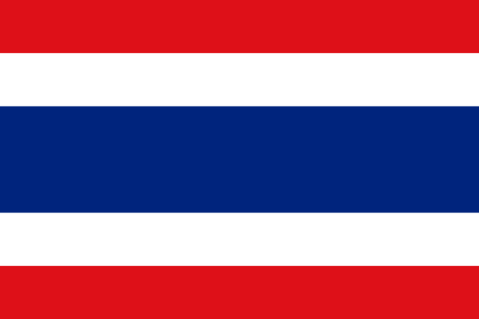
You will need:
- Red, blue and white material (paper, fabric, ribbon, buttons, etc.)
- Pens
- Scissors
- Glue

Memory game
Girls need to get into teams of 4 or 5 girls. Number yourself 1 to 4 or 5 and get ready.
You will be supplied with different pens, and a large sheet of A4 white paper.
One at a time each girl will go up and remember as much as they can about the map:
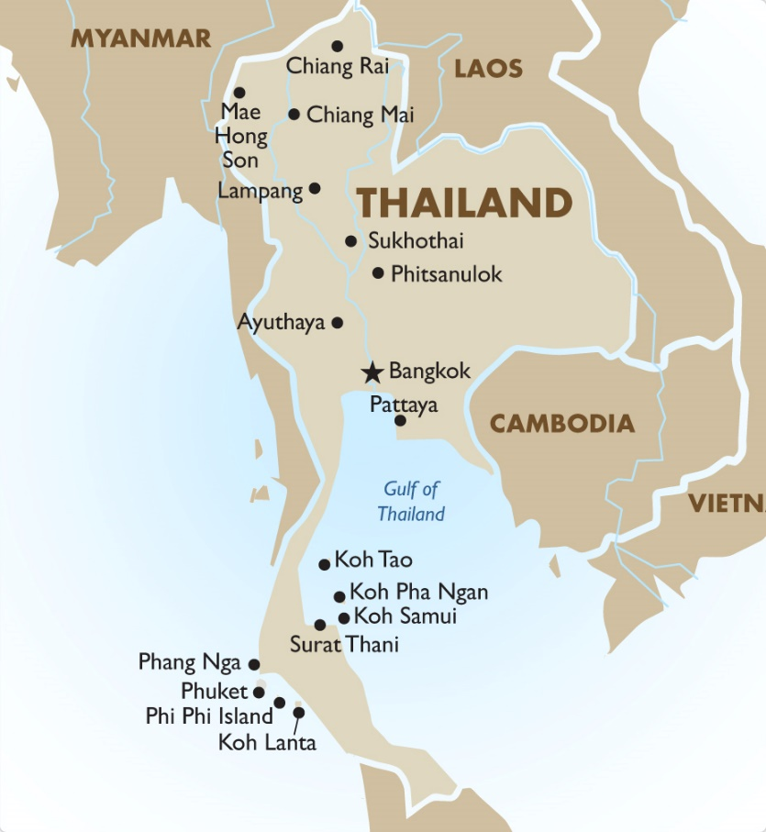
They will look at it for a minute and then go back to their group. They will then communicate all the information they remember about the map without touching any of the pens or the paper. They will then repeat this with the next girl and so on for 2/3 minutes.

Delicious Thai Food
At one of our planning & preparation weekend for Thailand, we made delicious traditional Thai food. Have a try at making some of these traditional Thai recipes, they are easy to make.
Before you begin, check that no one has an allergic reaction to any of the ingredients then make sure long hair is tied back, hand are washed and put on your apron!
Thai green chicken curry (alternatively this can be made vegetarian by replacing the chicken thighs with Quorn pieces)
Prep time: approx. 30mins
Cooking time: 10-30mins
Serves: 4
Ingredients
- 1 tbsp vegetable oil
- 2 tbsp ready-made Thai green curry paste
- 6 chicken thighs, skin and bones removed, meat cut into strips
- 400ml tin coconut milk
- 2 lime leaves (optional)
- 2 tbsp Thai fish sauce
- 1 tbsp caster sugar
- handful green beans, trimmed
- handful asparagus spears
- salt and freshly ground black pepper

Recipe
- Heat the oil in a wok over a high heat until smoking. Add the green curry paste and stir fry for 1–2 minutes, or until fragrant.

- Add the chicken strips and stir until coated in the curry paste. Continue to stir-fry for 1–2 minutes, or until the chicken has browned on all sides.

- Add the coconut milk, lime leaves, fish sauce and sugar and stir well. Bring the mixture to the boil, then reduce the heat until the mixture is simmering. Continue to simmer for 8–10 minutes, or until the sauce has thickened.

- Add the green beans and asparagus and continue to simmer for 2–3 minutes, stirring regularly, until just tender. Season with salt and pepper.

- To serve, spoon the rice into four serving bowls, then ladle over the Thai green chicken curry. Sprinkle over the coriander leaves.

Thai Vegetable Broth
Prep time: approx. 15mins
Cooking time: 10mins
Serves: 4
Ingredients
- 1½ tbsp Thai red curry paste*
- 1 tsp vegetable oil
- 1l vegetable stock
- 400ml can half-fat coconut milk
- 2 tsp brown sugar
- 175g medium egg noodles
- 2 carrots, cut into matchsticks
- ½ head Chinese leaf, sliced
- ½ x 300g bag beansprouts
- 6 cherry tomatoes, halved
- Juice of 1 lime
- 3 spring onions, halved, then finely sliced lengthways
- Handful coriander, roughly chopped
* Recipe tip: Many curry pastes contain dried shrimp and fish sauce. Read the labels carefully if you want to make this a vegetarian dish. If you're cooking this for meat-eaters, try adding shredded leftover roasted chicken. ONLY if no one has an allergic reaction to coconut milk, you can add 400ml can half-fat coconut milk to make it truly authentic.

Recipe
- Place the curry paste in a large saucepan or wok with the oil. Fry for 1 min until fragrant. Tip in the vegetable stock, coconut milk and brown sugar. Simmer for 3 mins.

- Add the noodles, carrots and Chinese leaf and simmer for 4-6 mins, until all are tender.

- Mix in beansprouts and tomatoes.

- Add lime juice to taste and some extra seasoning, if you like.

- Spoon into bowls and sprinkle with spring onions and coriander.

Thai dip and prawn crackers
Prep time: approx. 5mins
Cooking time: 10mins
Ingredients
- 2 tsp of Thai Curry paste
- 1 tsp tomato puree
- 100mn coconut cream
- ½ tsp sugar
- ½ tsp soy sauce
- ¼ of lime, juiced
- Packet of Thai prawn crackers

Recipe
- Put all ingredients into a saucepan and bring to the boil

- Reduce the heat and simmer for 5 minutes until slightly thickened

- Leave to cool then pour into a bowl and serve with Thai prawn crackers

Origami fish
Did you know that the Siamese fighting fish is the national fish of Thailand? Neither did we! Which is why we have added in this paper craft.
You will need:
- Square coloured paper

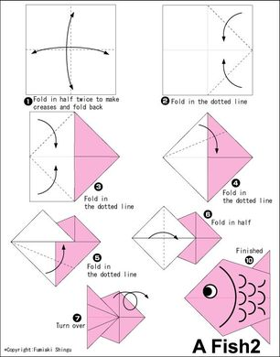

Breaking barriers
In Thailand, the education system isn’t too bad, however, many of the opportunities which are posed to men are not posed to women as well. As we will find out, many sports in Thailand are segregated. Boys play football. Girls play volleyball. How does that make you feel? Make a drama about different issues which you have faced which are sexist or have made you feel bad about yourself.
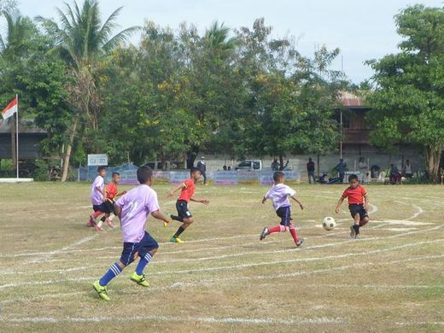

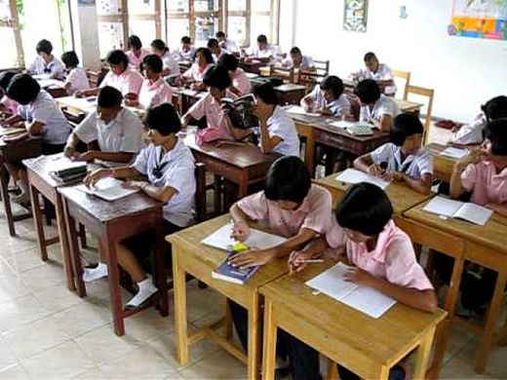

Kites
Kites are a tradition in Thailand. They are often given and/or made during major festivals or celebrations
Why don’t you have a go at making one?
You will need:
- Paper (white or coloured)
- Paints/colouring pens
- Paint brushes
- String
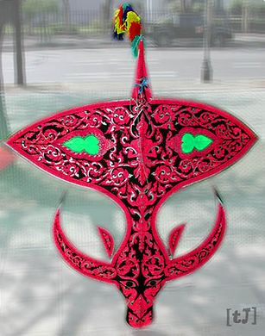
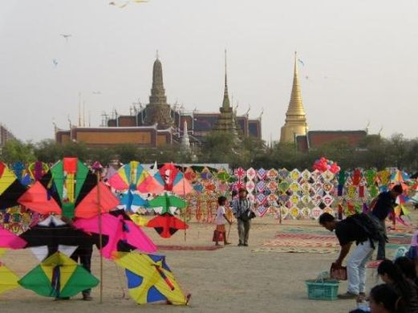
- Straws or skewers

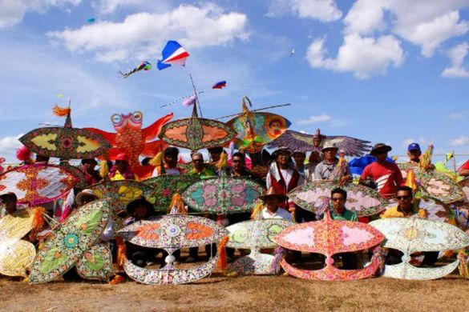
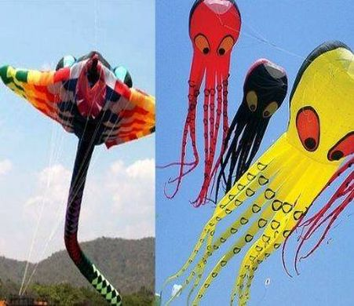

Basic Thai games
Duck and Goose (Mon Son Pha)
This game starts with a group of kids sitting in a circle. One person is picked to be Mon. Mon walks slowly around the circle with a cloth, and drops it behind another player. The chosen player picks up the cloth and chases Mon around the circle. Mon tries to get to the empty spot and sit down before the player can tag them. If they make it, the player with the cloth becomes the new Mon.
Crow Hatches Eggs (I Ka Fak Khai)
Start by drawing a big circle on the ground large enough to fit all the players. Inside that, draw a smaller circle for only one person. Each player puts a marble, a piece of paper marked with their name, or a small stone inside the inner circle. These are the eggs. One person is the crow and stands in the small circle. The crow uses their arms and legs to try to block other players from stealing the eggs.
The other players try to grab the eggs without touching the crow or stepping in the small circle. And they must stay inside the larger circle. When all the eggs are stolen, the crow covers their eyes and counts to 20. The other players hide their eggs nearby – maybe behind a tree or wall. The crow must hunt for the eggs. The owner of the first egg the crow finds becomes the next crow. Everyone collects the eggs and a new game starts.
Snake eats Tail (Ngu Kin Hang)
Pick one father snake and one mother snake. Everyone else lines up behind the mother snake and holds the waist of the person in front of them. As the mother and babies sway side to side, Father snake calls out, “Which well do you drink from?” Mother snake answers, “I drink from a well in the stone.” Mother and babies call out together “We do too.” The father says what part of the mother snake he will bite (end or middle) and begins to chase after the babies. The mother puts her arms out to block the father as the line of babies runs to keep out of the father’s reach. When the father tags one of the babies, they are out. The game is over after the father tags all the babies.
One-Legged Rabbit (Kratai Kha Diao)
Form two teams of equal size: one team of rabbits and a second team of players. Then mark off a square large enough for the second team to stand inside and move around. The rabbits stand outside the square. One rabbit at a time hops on one leg into the square and tries to tag as many of the second team as they can. Players inside the square are out if they are tagged or if they cross the boundary by mistake. A rabbit it out if they put their other foot down or change leg. If a rabbit gets tired, they can hop back out and ask another rabbit to take their place. The game is over when all the players in the square are tagged out, or if all the rabbits are out first.

Painted umbrellas
Thailand is hot most of the year. Everywhere you go you’ll see people walking with umbrellas to stay out of the hot sun. Near Chiang Mai, villagers made hand-painted paper umbrellas in beautiful colours, painted with flowers, birds and other pictures.
Have a go at making one.
You will need:
- Paint (multiple colours)
- Paint brushes
- Paper umbrellas
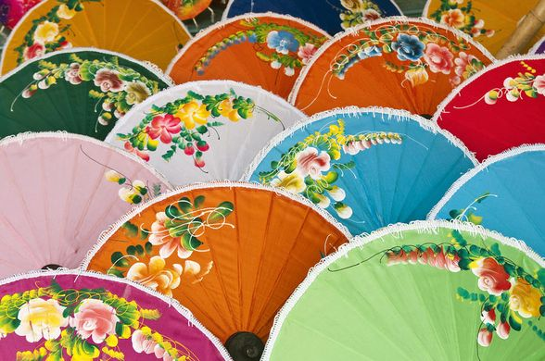

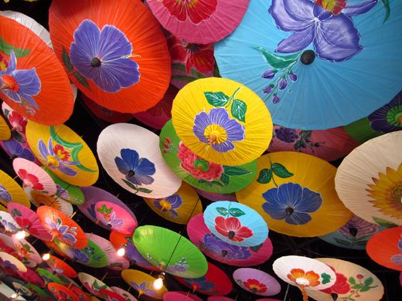

Prayer flags
Prayer flags are often made at the Thai New Year. These are often their wishes for the next year.
Have a go at making your own.
You will need:
- Coloured paper
- Coloured pens
- Scissors
- Glue
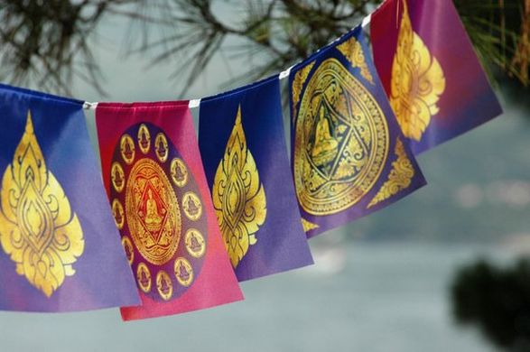

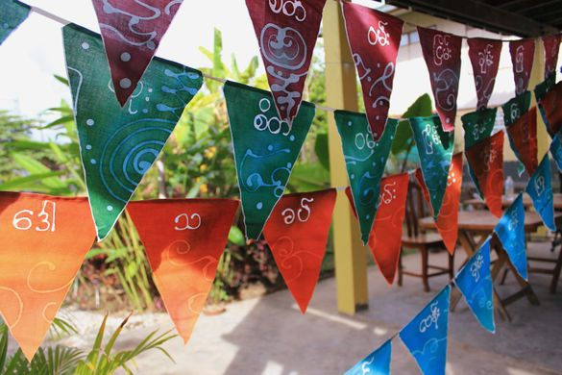

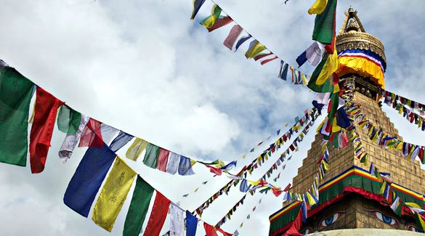

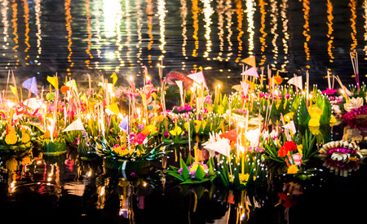
The Floating Lantern Festival

Loi Krathong
Children love the beautiful Loi Krathong, or Floating Lantern Festival, that happens each November during the full moon. Loi means to float, and Krathong means little boat of banana leaves. We sail small boats with lighted candles down rivers and canals to honour Buddha and ask the Goddess of Water, Phra Mae Khongkha, to bring plenty of water for growing our rice the next year. The boats also carry away our bad luck from the past year.
The boats are decorated to look like a lotus blossom. At Thai schools they make boats in the traditional way with thick round slices of banana tree branches at the base. This is wrapped in banana leaves. They are decorated with more leaves and flowers, and candle, incense and a small coin is added to the middle of the flowers. Sometimes something personal is added. The children get very excited putting their boat in the water and watch it float away as they make wishes to Buddha and the Goddess of Water.
As the bad luck of the past year floats away, people also let go of mistakes and start fresh. This lovely song speaks of the Buddhist concept of “making merit”. Merit is made when the Thai people accumulate good thoughts and deeds, and treat each other with compassion.
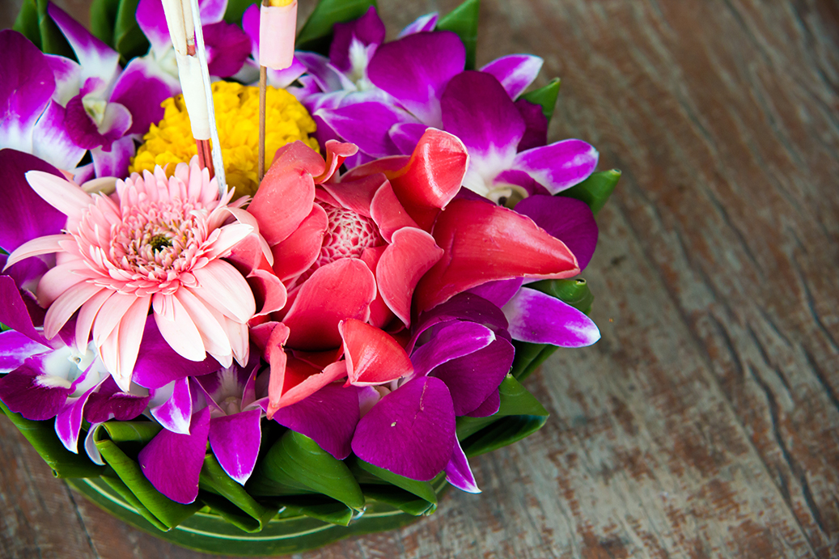

Make your own Lantern Boat!
You can make your own Loi Krathong boat to celebrate the holiday just like we do in Thailand! You can go to a local river or pond, light your candle and incense, and set the boat adrift. Be sure to make some special wishes.

You will need:
- 1 round paper mache box (7 ½ inch across and 3 inches deep – or 19 by 8 cm)
- 7 ½ inch round of corkboard
- Green and pink construction paper
- Fresh flowers in season (optional)
- Glue
- Double sided tape
- Ruler, pencil and scissors

Method:
- Glue corkboard to the bottom of the paper mache box.
- Cut out green construction paper to cover sides and top of box and glue on.
- Cut out paper petals and glue them to the side of the box with the top 1/3 of the petals standing above the top of box.
- Add fresh flowers or make a large lotus flower. (Cut out petals, bend at bottom, and glue to a small round base, alternating white and pink. Petals should stand up.)
- Add a small candle in the middle, securing it with double sided tape. If you like, use tape to add incense, a penny and anything special you want to offer to the water goddess (like a special rock or shell).

“The Toong” - Thai Lanna long flag
At our selection weekend, when we found out we would be going to Thailand, we made sections of a Lanna flag. Each girl made a square and then our Leaders strung them together with wool and ribbon to form a long flag.
Why not try making a Lanna flag for your unit?
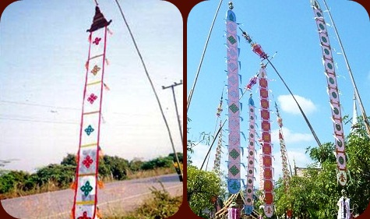
You will need:
- A4 coloured paper, tissue paper, wool
- Coloured felt tip pens
- Scissors
- Glue
- Whole punch

Method:
- Decide on a theme for your Lanna flag
- Either create a square from A4 paper or fold in half to create two A5 sheets.
- Based on your theme, draw or create your design on the paper
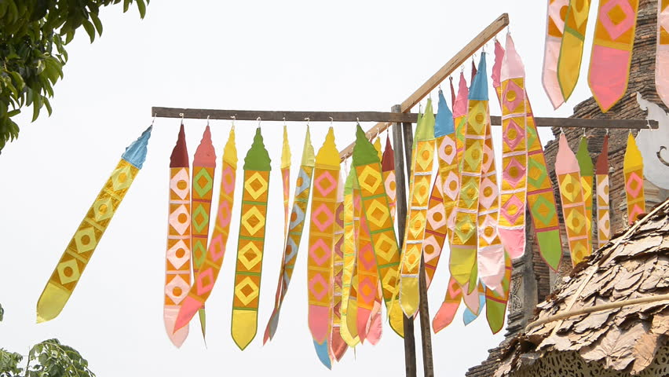
- When finished, create a hole at each corner and using the wool attach each of the finished designed paper together

Thailand LaSER 2019 Badge Order Form

Contact name
Unit name
Phone number
Email address
Contact address (for badges to be sent to)

Post code

Number of badges | Total
@ £1 per badge
Postage and packaging
(see below for rates)
Total cost:
Please make cheques payable to
‘Girlguiding LaSER International Account’

Please send cheque and order form to ‘Thailand LaSER Activity Pack, c/o Jennie Barnes, 12 Linnet Green, Ridgewood, Uckfield, East Sussex, TN22 5YD’
For any queries regarding badge orders contact jenniebarnes38@hotmail.com
Postage & Packaging
1-25 badges £1.50
25-50 badges £2.50
50-100 badges £3.50
For 100+ badges or international orders, please contact Jennie at the email address above.

