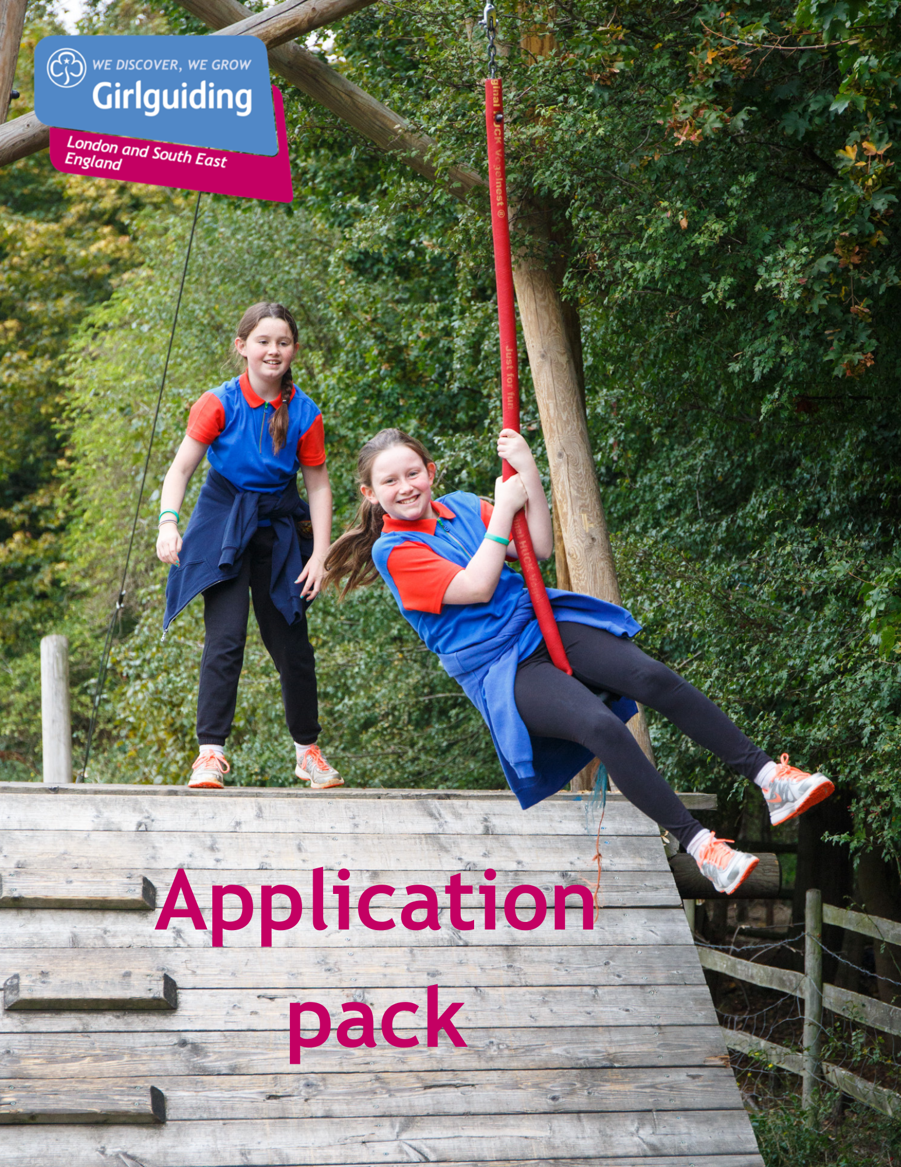

Girlguiding LaSER

Trainer Coordinator
Voluntary

About Girlguiding

Girlguiding is the leading charity for girls and young women in the UK, with over a half a million members, including over 100,000 trained volunteer adult leaders and supporters.

We are active in every part of the UK, giving girls and young women a space where they can be themselves, have fun, build brilliant friendships, gain valuable life skills and make a positive difference to their lives and their communities. We build girls’ confidence and raise their aspirations. We give them the chance to discover their full potential and encourage them to be a powerful force for good.

Young members are grouped by age into five sections: Rainbows, Brownies, Guides and Rangers.

Girlguiding is independently operated through three countries; Scotland, Wales and Northern Ireland and six English regions; North West England, North East England, Midlands, Anglia, South West England and London & South East England, each having their own headquarters employing core staff.

About Girlguiding LaSER

The role of Girlguiding London and South East England (LaSER) is to deliver the business of Girlguiding in London and South East England Region.

We offer girls and young women quality girl-led guiding opportunities, presenting challenge and adventure, which develop their potential and enable them to make a positive contribution to their community and beyond. We also provide training and support for adult volunteers.

The LaSER headquarters is based in Wandsworth Common.

Purpose of the Role

Working with qualified trainers to ensure their CPD needs are met to maintain quality standards and renewals are up to date.

Role Responsibilities

- Identifying and ensuring that trainers receive the necessary training and support to carry out their role.
- Reviewing trainer annual record forms to identify CPD needs and training skills available within the team
- Organising an annual trainer conference - alternating between 1 day or 2 day events in alternate years
- Ensuring that trainers undertake the renewal process on their qualification every three years, if they wish to continue to train. Arranging these trainer renewal observations, reviewing paperwork and signing off
- Reviewing requests for trainers from counties or region and sending out via the office to the trainers. Following up and linking trainers if gaps still exist.
- Responding to concerns or complaints raised by or about trainers
- Linking with county training advisers twice a year for networking and CPD
- Attending national meetings & providing reports & data as required
- Providing ongoing administrative support to the region by coordinating and organising matters related to training, often by email.
- Keeping up to date with new resources and programme initiatives, disseminating to the trainer team and using them as appropriate.
- Ensuring all the necessary records are maintained.
- Attending region Learning & Development meetings and other meetings and events as appropriate
- Providing regular reports to the Learning & Development Lead Volunteer as required
- Promoting Girlguiding LaSER and Girlguiding generally.
- Portraying a positive image of Girlguiding LaSER and Girlguiding.
- Working within designated budgets related to Trainers

Person Specification

Criteria | Essential / Desirable | Evidence
Skills
Good organisational skills | Essential | Application/Interview
Good oral and written skills | Essential | Application/Interview
Ability to work as part of a team | Essential | Application/Interview
Ability to work with information of a confidential or sensitive nature | Essential | Application/Interview
Good time management skills | Essential | Application/Interview
Ability to use and access the internet and email. | Essential | Application/Interview
Experience
Be an experienced Trainer or training adviser | Essential | Application/Interview
Good overall knowledge of training qualification and training specialism | Essential | Application/Interview
Experience in managing people | Essential | Application/Interview
Behaviours
Be creative and enthusiastic; open to new ideas and willing to find better ways of working | Desirable | Application/Interview
Be committed to on-going personal development | Desirable | Application/Interview
Positive response to change and ability to support others through change | Desirable | Application/Interview
Confidence to have challenging conversations. | Desirable | Application/Interview
Ability to motivate and inspire adult volunteers | Desirable | Application/Interview

Employment Details

Voluntary (Appointment for initial 3 year term, extension for 2 years maximum)

There is no remuneration for this post, but all reasonable expenses will be reimbursed.

How to Apply

Closing date: Thursday 13 August at 9 am.
Interview date: TBC
How to apply: Please email recruitment@girlguidinglaser.org.uk with a small statement on why you’re interested and what you could bring to the role.

If you have any questions about the role please direct them to Fiona Jackson, Learning & Development Lead Volunteer at recruitment@girlguidinglaser.org.uk

