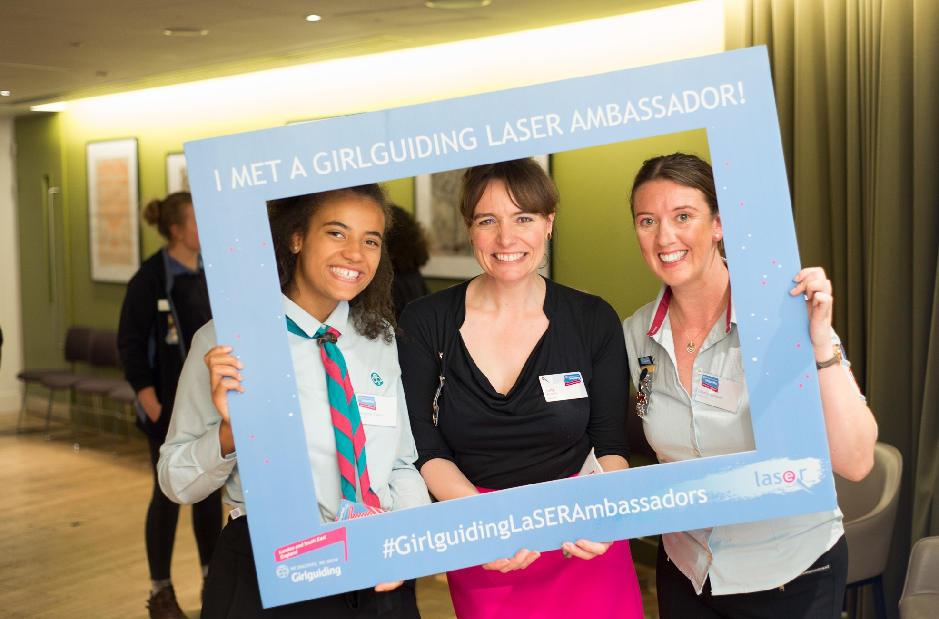

Trustee Pack

Contents

Welcome . . . . . . . . . . . . . . . . . . . . . . . . . . . . . . . . . . . . . . . . . . . . . .
2

1. about Girlguiding LaSER. . . . . . . . . . . . . . . . . . . . . . . . . . . . . . . . . .
3

2. about the Girlguiding LaSER Board of Trustees . . . . . . . . . . . . . . . . . . .
4

3. Responsibilities of trustees. . . . . . . . . . . . . . . . . . . . . . . . . . . . . . . .
5

4. Trustee person specification . . . . . . . . . . . . . . . . . . . . . . . . . . . . . . .
6

5. Skills needed . . . . . . . . . . . . . . . . . . . . . . . . . . . . . . . . . . . . . . . . .
7
8

6. 2020 meeting schedule 8
8

7. How to apply . . . . . . . . . . . . . . . . . . . . . . . . . . . . . . . . . . . . . . . . .
8

8. Application Form . . . . . . . . . . . . . . . . . . . . . . . . . . . . . . . . . . . . . .
9

1
Girlguiding LaSER Trustee Application Pack

Girlguiding London & South East England is an operating name of The Guide Association London & South East England Region. Registered Charity No. 308268

Welcome
Thank you for your interest in becoming a trustee with Girlguiding LaSER.

As a member of Girlguiding LaSER you will already know how fabulous our movement is and the amazing contribution we make to the lives of girls and young women across the region. In addition to our membership of over 70,000, we employ 17 staff and our turnover is £1.04 million.

We are totally committed to ensuring the personal development of girls and young women through our challenging and exciting programmes. Our trustee board provides strategic leadership and direction to take Girlguiding LaSER forward. The role of a trustee offers varied and challenging opportunities for people who want to help shape Girlguiding LaSER’s future.

We are now seeking to appoint new membership trustees including at least one aged between 18 and 30. This pack contains further information about our structure, the role and person specification for the trustee together with an application form and details of how to apply.

I hope that after reading this pack you will feel motivated and encouraged to apply for the role. If you would like to discuss the role before you decide, then please get in touch at trustee@girlguidinglaser.org.uk to arrange a mutually convenient time to have an informal
chat.

We very much look forward to hearing from you.

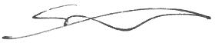

Sally Christmas Chief Commissioner

2
Girlguiding LaSER Trustee Application Pack

Girlguiding London & South East England is an operating name of The Guide Association London & South East England Region. Registered Charity No. 308268

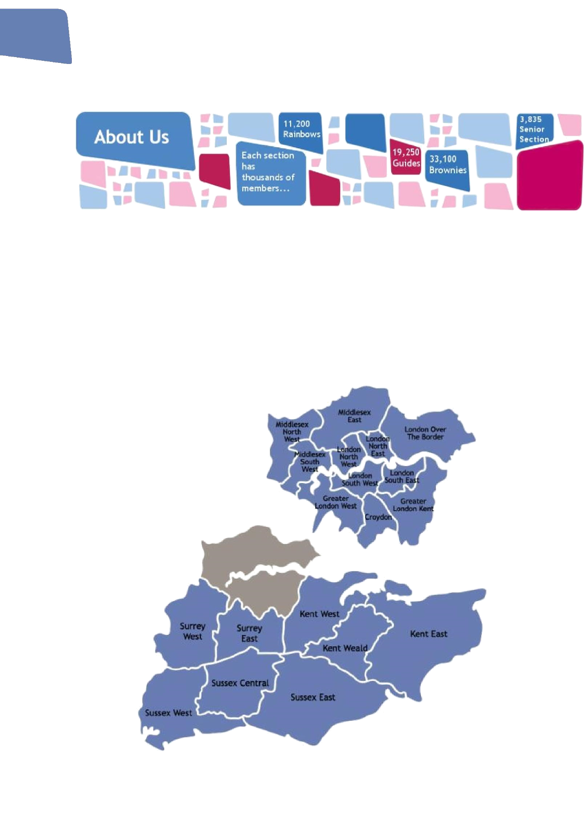
About Girlguiding LaSER

Girlguiding London and South East England region (LaSER) is divided into 19 counties covering Greater London, Surrey, Sussex and Kent.

We are the leading charity for girls and young women with over 70,000 Rainbows, Brownies, Guides, Rangers and volunteers.

For more information visit www.girlguidinglaser.org.uk

3
Girlguiding LaSER Trustee Application Pack

Girlguiding London & South East England is an operating name of The Guide Association London & South East England Region. Registered Charity No. 308268

About the Girlguiding LaSER Board of Trustees
Trustee Board
Steering Group
Marketing and Communications
Risk Group

Property Group
Operations Group
Adventure and Activities

Learning and Development

Composition of the Trustee Board: - 10 – 13 Trustees

- Membership to include:

- Chief Commissioner (Chair of Trustees, unless she appoints her deputy to take on this role)
- Deputy Chief Commissioner
- Trustee Treasurer
- Two County Commissioners
- 4 places from Girlguiding LaSER membership who bring the skills required of the Trustee role, at least two of these from the 18 to 30 age group.
- Two external appointments
- Region Manager attends

The additional two places may be used to ensure that there is an appropriate range of skills within the Trustee Board to deliver its purpose.

4
Girlguiding LaSER Trustee Application Pack

Girlguiding London & South East England is an operating name of The Guide Association London & South East England Region. Registered Charity No. 308268

Purpose and role to include:-

  - To direct Girlguiding London and South East England Region (LaSER)
  - To be Trustees of Girlguiding LaSER
  - To approve the Statement of Purpose and Strategic Plan
  - To ensure all activities and events are within the strategic direction of the Region
  - To ensure that vision and values of Girlguiding are operated in Girlguiding LaSER
  - To receive reports and feedback from the Steering and Operational Groups
  - To provide wide representation of Girlguiding LaSER members
  - To ensure financial viability of the organisation including long term financial strategy, and monitoring of income and expenditure
  - To ensure effective communication between the Chief Commissioner, Trustee Board and other groups within the Girlguiding LaSER structure
  - To provide support and challenge to the Region Manager

Responsibilities of trustees
The Girlguiding LaSER Board of Trustees has overall legal responsibility for the direction, management and control of Girlguiding LaSER, and is collectively accountable for compliance with relevant legislative and regulatory requirements. Girlguiding LaSER’s day- to-day operations are undertaken by Girlguiding LaSER staff and volunteers under the overall leadership and supervision of the trustees.
Trustees have legal duties and responsibilities and make decisions collectively. Everyone has the responsibility to contribute to discussions and decisions. However, once that decision has been taken they have a further responsibility to uphold and support that decision. All matters discussed in closed sessions must be regarded as strictly confidential.
Being a trustee is a voluntary role, undertaken because you have a commitment to furthering the purposes of Girlguiding LaSER and have the skills, experience and personal qualities needed for the strategic management of the organisation. All reasonable expenses will be reimbursed.
To serve as a trustee you must be over the age of 18 and not disqualified because of bankruptcy, unspent criminal convictions for offences of deception or dishonesty, or a legal order for removal/disqualification as a trustee or company director. It is a criminal offence to act as a trustee while disqualified.

For more information on becoming a trustee and what is involved, please see the Charity Commission webpage: www.charitycommission.gov.uk/trustees-staff-and-volunteers/trustee- role/becoming-a-trustee/

5
Girlguiding LaSER Trustee Application Pack

Girlguiding London & South East England is an operating name of The Guide Association London & South East England Region. Registered Charity No. 308268

Trustee person specification

Trustees will be expected to bring the following:

- A commitment to Girlguiding LaSER and a proactive interest and enthusiasm in shaping and advising on the future of Girlguiding LaSER.
- A willingness to devote the necessary time and effort to attend meetings including undertaking the appropriate preparation work.
- Good independent judgement and the ability to give constructive challenge.
- An ability to think creatively and strategically.
- An understanding and acceptance of legal duties, responsibilities and liabilities of trusteeship and the roles of boards.
- An ability to work effectively as a member of a team.
- A commitment to Nolan’s seven principles of public life: selflessness, integrity, objectivity, accountability, openness, honesty and leadership.
- Strong communication skills and the ability to analyse and interpret information.
- Be at least 18 years of age.

6
Girlguiding LaSER Trustee Application Pack

Girlguiding London & South East England is an operating name of The Guide Association London & South East England Region. Registered Charity No. 308268

Skills needed (Each person needs to demonstrate only some of these)

- Audit and risk management
- Strategic planning
- Youth participation in practice
- Finance and investment
- IT
- HR and recruitment
- Strategic partnerships
- Marketing/innovation/creative
- Fundraising and income generation
- Membership communications and PR
- Social media/digital
- Education policy and practice
- Public policy development
- Legal and safeguarding
- Management and leadership of volunteers
- Performance management/measuring impact
- Business/commercial experience
- Experience/capability
- Chair a meeting/committee
- Represent Girlguiding LaSER externally
- Represent Girlguiding LaSER internally
- Operational guiding leadership
- Guiding membership experience
- Guiding volunteering experience
- Charity governance and management
- Other governance experience
- Understanding of the wider guiding family (including Trefoil Guild, WAGGGS, BGIFC, SSAGO, and Branch Associations)

7
Girlguiding LaSER Trustee Application Pack

Girlguiding London & South East England is an operating name of The Guide Association London & South East England Region. Registered Charity No. 308268

2020 Meeting Schedule

Trustee Board:

Sunday 9th February Sunday 19th April Saturday 11th July Sunday 1st November

How to apply

You must put yourself forward for election. Please complete the application form to include a personal statement outlining:
- How you feel you fulfil the person specification outlined on page 6.
- Which of the skills from the list on page 7 you feel you bring
- Why you wish to be considered for a role on the Girlguiding LaSER Board of Trustees.

Please give examples where you can of the skills and knowledge you have, these may have been gained either from inside guiding or from your work or other volunteer roles outside of guiding.
(Please note those people employed by Girlguiding and Girlguiding LaSER cannot apply for a trustee position).

Please email your application in confidence to trustee@girlguidinglaser.org.uk For the attention of: Sally Christmas, Chief Commissioner and Chair of Trustees. Your application must be received by midnight on 1 February 2020.
Shortlisted applicants will be invited for interview to be held on 15 February 2020.

8
Girlguiding LaSER Trustee Application Pack

Girlguiding London & South East England is an operating name of The Guide Association London & South East England Region. Registered Charity No. 308268

Trustee Application Form

Full Name:
Preferred Name:
Girlguiding Membership No:

Contact Details:
Home Telephone No:
Mobile:
Work No:
Email Address:

Current Girlguiding Role/s:
Role | Unit / District | Division | County

Previous Girlguiding Role/s:
Role | Unit / District | Division | County

Personal Statement
  - Please provide a personal statement detailing the experience that you feel you could offer as a trustee for Girlguiding LaSER
  - How you feel you fulfil the person specification outlined on page 6
  - Which of the skills listed on page 7 you feel you can offer, with brief examples of when you have used these skills
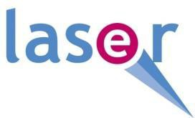
  - Why you wish to be considered as a Girlguiding LaSER Trustee
  - Your personal statement should be no more than 1000 words

Trustee Application Form - Personal Statement

