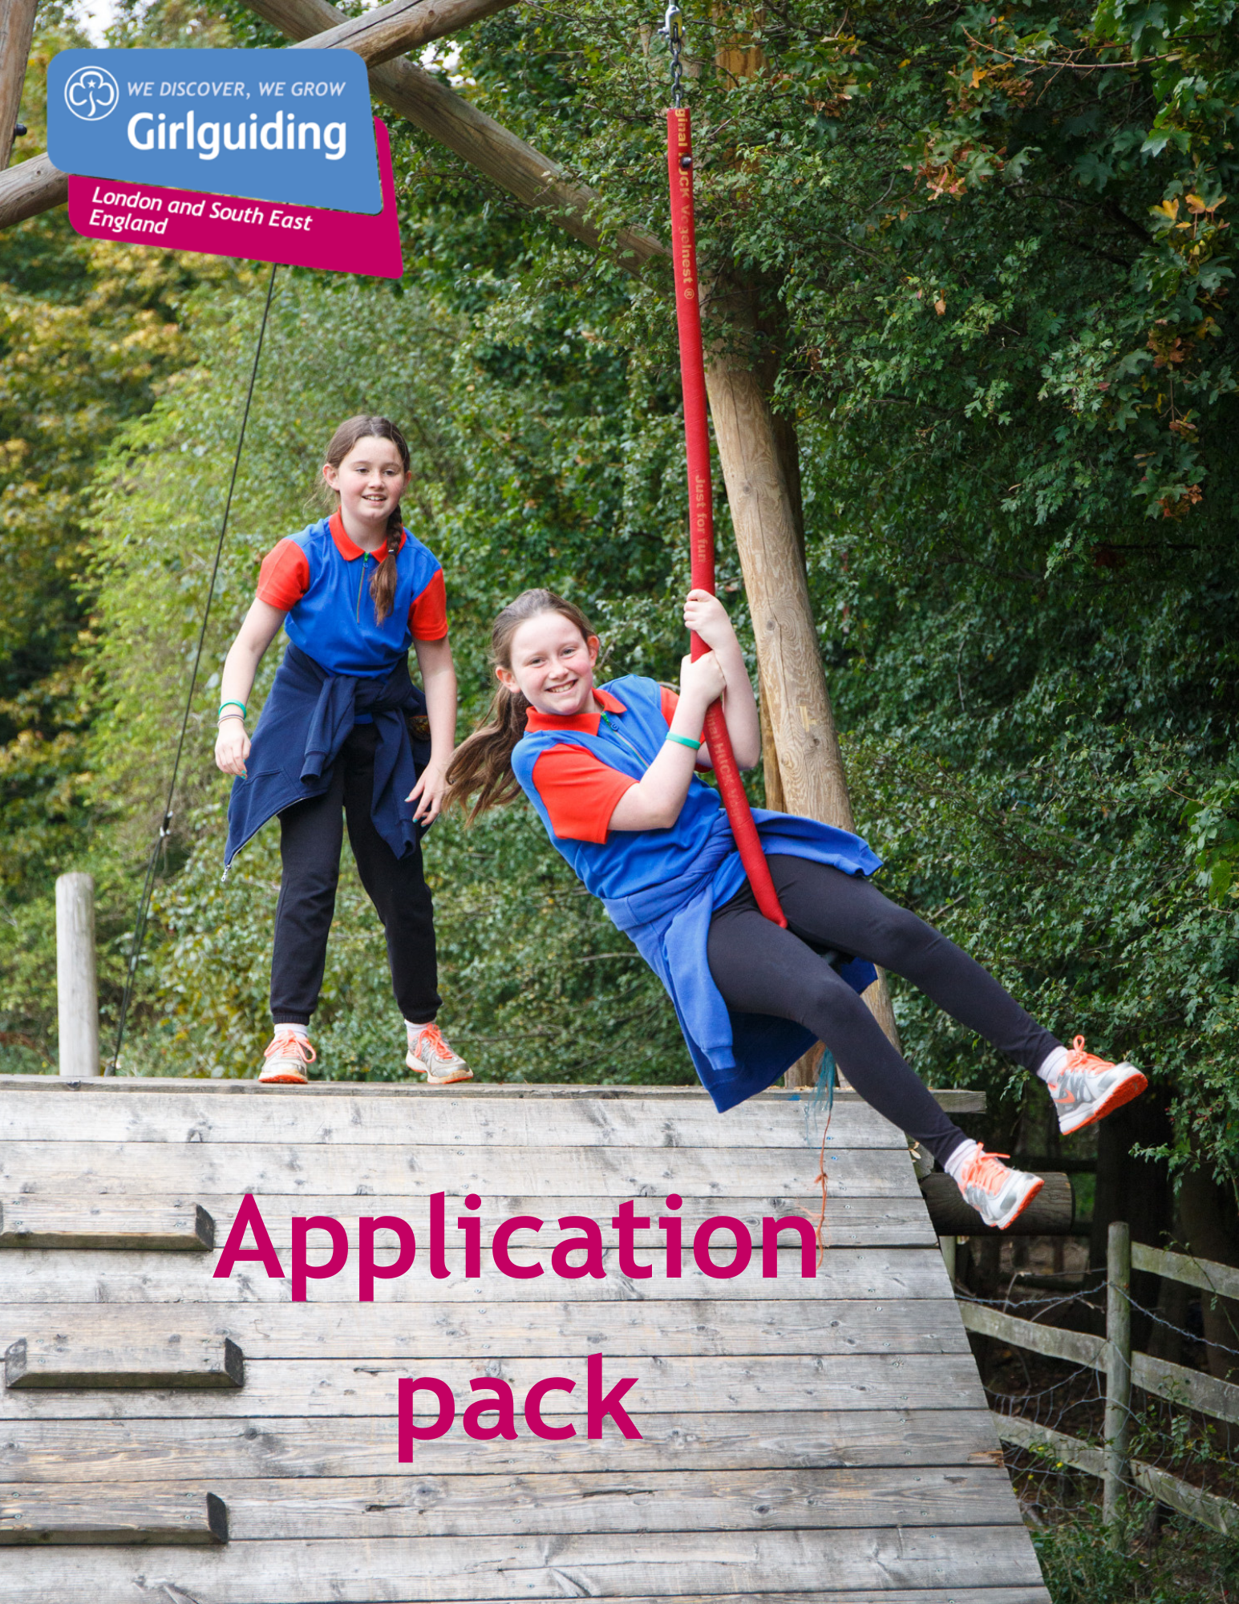

Girlguiding LaSER

Essential Training Coordinator
Voluntary

About Girlguiding

Girlguiding is the leading charity for girls and young women in the UK, with over a half a million members, including over 100,000 trained volunteer adult leaders and supporters.

We are active in every part of the UK, giving girls and young women a space where they can be themselves, have fun, build brilliant friendships, gain valuable life skills and make a positive difference to their lives and their communities. We build girls’ confidence and raise their aspirations. We give them the chance to discover their full potential and encourage them to be a powerful force for good.

Young members are grouped by age into four sections; Rainbows, Brownies, Guides and Rangers and for young women aged 18-30 we have Inspire.

Girlguiding is independently operated through three countries; Scotland, Wales and Northern Ireland and six English regions; North West England, North East England, Midlands, Anglia, South West England and London & South East England, each having their own headquarters employing core staff.

About Girlguiding LaSER

The role of Girlguiding London and South East England (LaSER) is to deliver the business of Girlguiding in London and South East England Region.

We offer girls and young women quality girl-led guiding opportunities, presenting challenge and adventure, which develop their potential and enable them to make a positive contribution to their community and beyond. We also provide training and support for adult volunteers.

The LaSER headquarters is based in Wandsworth Common.

Purpose of the Role

Understanding and ensuring the current and future needs for all mandatory training (currently Safe Space, First Response, plus leadership training) for the Region’s adult volunteers is met.

Role Responsibilities

- To be the point of contact for all mandatory training; Safe Space, First Response and Leadership Training
- Understand demands for this training in the region and ensure sufficient capacity to meet this demand exists working across National, Regional and County capacity.
- Schedule region training and coordinate trainers for these.
- Oversee communications to ensure compliance including reminder emails for those due to expire
- To link into HQ on all aspects of mandatory training to understand changes and help trainers stay up to date.
- Drive a campaign to flatten out the peaks and troughs in renewals coming up to ensure demand can be met.
- To be the point of contact for county training advisors on mandatory training – keep them updated and understand county requirements.
- To lead on ensuring compliance across the region including oversight of mail-outs to those who are at risk of withdrawal for Safe Space Level 3 & 4 as well as Commissioner mailings
- Attending national meetings & providing reports & data as required
- Ensuring all the necessary records are maintained.
- Attending region Learning & Development meetings and other meetings and events as appropriate.
- Providing regular reports to the Learning & Development Lead Volunteer as required.
- Promoting Girlguiding LaSER and Girlguiding generally.
- Portraying a positive image of Girlguiding LaSER and Girlguiding.
- Working within designated budgets related to role.
- If required support the rollout of the new Learning Platform to ensure no interruption to the current programme of essential training rollout.

Person Specification

Criteria | Essential / Desirable | Evidence
Skills
Good organisational skills | Essential | Application/Interview
Good oral and written skills | Essential | Application/Interview
Ability to work as part of a team | Essential | Application/Interview
Ability to work with information of a confidential or sensitive nature | Essential | Application/Interview
Good time management skills | Essential | Application/Interview
Ability to use and access the internet and email. | Essential | Application/Interview
Ability to understand data to model future training requirements | Essential | Application/Interview
Experience
Be an experienced Trainer or training adviser | Essential | Application/Interview
Good overall knowledge of mandatory training | Essential | Application/Interview
Experience in managing people | Essential | Application/Interview
Behaviours
Be creative and enthusiastic; open to new ideas and willing to find better ways of working | Desirable | Application/Interview
Be committed to on-going personal development | Desirable | Application/Interview
Positive response to change and ability to support others through change | Desirable | Application/Interview
Confidence to have challenging conversations. | Desirable | Application/Interview
Ability to motivate and inspire adult volunteers | Desirable | Application/Interview

Employment Details

Voluntary (Appointment for initial 3 year term, potential extension for 2 years maximum following discussion)

There is no remuneration for this post, but all reasonable expenses will be reimbursed.

A role share for this role would be considered and the role split between supporting Safe Space and First Response separately if suitable candidates are interested.

How to Apply

Closing date: Applications are welcome at any time
How to apply: Please email recruitment@girlguidinglaser.org.uk with a small statement on why you’re interested and what you could bring to the role.

If you have any questions about the role please direct them to Fiona Jackson, Learning & Development Lead Volunteer at ldlead@girlguidinglaser.org.uk.

